ABSTRACT
Both Production Forecasting and Pressure Anomaly Detection are essential and challenging problems in Petroleum Engineering, directly impacting reservoir management, operational safety, and investment decisions. In this paper, Random Forest Regressor was used to address the production forecasting and Isolation Forest was applied for the pressure anomaly detection. Both were investigated using historical data of Volve Field which is a mature offshore oilfield in the Norwegian North Sea, operated by Equinor. For production forecasting, a feature engineering process was designed based on historical data of Well F-12. Random Forest Regressor was then trained with historical data from 2007 to 2015 and tested with data from 2015 to 2016. It obtained R-squared of 0.9494 (training) and R-squared of 0.9325 (testing), with the test RMSE value of 31.83 STB/D. A 3-method hybrid framework was established to detect pressure anomaly from Well F-12 (2008 to 2010), where multivariate Isolation Forest was used. Among 955 valid pressure readings, 24 anomalies were detected by the system and root-cause investigation revealed that these anomalies were caused by well shutdown, water breakthrough, choke change and unspecified reason. Classified according to confidences, 1 High, 8 Medium and 15 Low-confidence anomalies were obtained. These analysis reveal that Random Forest and the developed ensemble anomaly detection are powerful tools for monitoring well performance.

CHAPTER 1: INTRODUCTION
Production Forecasting in Petroleum Engineering is the systematic process of estimating how much oil, gas, and water, a reservoir will produce in the future. These predictions are made using historical production data, reservoir properties (such as pressure, permeability, and porosity), operational conditions, and economic considerations. In simple terms, production forecasting helps engineers answer the question: "How will this field perform in the coming months or years?"
Pressure anomaly detection, on the other hand, focuses on monitoring downhole and wellhead pressures to identify abnormal events that could indicate equipment failure, flow restrictions, or safety issues. Downhole pressure directly influences production rates, equipment performance, reservoir management decisions, and operational safety. Abnormal pressure events such as sudden pressure drops, spikes, or oscillations, can indicate serious issues including equipment failure, scaling, hydrate formation, or unexpected reservoir behavior.
Production forecasting is extremely important because petroleum reservoirs naturally decline over time. As oil is produced, reservoir pressure decreases, water cut increases, and production rates change. Without forecasting, it becomes very difficult to plan field operations efficiently. Engineers rely on forecasts to design surface facilities, schedule drilling programs, plan maintenance activities, and manage production targets.
Similarly, pressure anomaly detection is critical because early detection of anomalies enables operators to take corrective actions before minor issues that can escalate into major production losses or safety incidents. Traditional pressure monitoring relies on fixed thresholds and simple alarm systems, but these approaches often generate false alarms and miss subtle precursors to failures.
In modern petroleum engineering, both production forecasting and pressure anomaly detection are closely linked with economic evaluation and operational safety. They help determine whether a field development plan is profitable and whether operations are proceeding safely. With the digital transformation of the oil and gas industry, large volumes of real-time production and sensor data are now available, making data-driven approaches more accurate than traditional methods.

1.1. Functions of Production Forecasting in the Petroleum industry
Production forecasting plays a critical role at every stage of an oil or gas field’s life. Its main functions are:
- Providing accurate and fast production estimates:
Production forecasting helps engineers quickly estimate future oil, gas, and water production. These estimates support timely technical and management decisions.
- Supporting field development planning:
Forecasting helps design development plans by deciding well spacing, production rates, and surface facility requirements.
- Understanding reservoir behavior:
By analyzing production trends, engineers can understand how the reservoir responds to production, such as pressure depletion or water breakthrough.
- Identifying production decline early:
Forecasting highlights declining production trends, allowing engineers to take corrective measures before major losses occur.
- Improving recovery efficiency:
It helps engineers choose suitable recovery methods to increase the amount of oil recovered from the reservoir.
1.2. Functions of Pressure Anomaly Detection in the Petroleum industry
Pressure anomaly detection plays a critical role at every stage of an oil or gas field’s life. Its main functions are:
- Equipment Protection:
Sudden pressure changes can damage downhole equipment, including pumps, packers, and tubing. Early detection prevents costly failures.
- Production Optimization:
Pressure data helps identify flow restrictions, scaling, or wax deposition that reduce production efficiency.

- Safety Assurance:
Abnormal pressure may indicate dangerous conditions such as kicks, losses, or well control events.
- Leak Detection:
Pressure drops can signal leaks in the wellbore or surface facilities.
- Preventing False Alarms:
Machine learning-based pressure anomaly detection reduces false alarms by learning normal pressure patterns and detecting only meaningful deviations.

CHAPTER 2: MACHINE LEARNING (ML) –

BASED METHODS
2.1. ML–BASED PRODUCTION FORECASTING METHODS
Machine learning–based forecasting methods represent a more recent and advanced approach to production forecasting. These methods use data-driven algorithms that can learn patterns directly from historical and real-time data. Unlike traditional methods, ML models do not require predefined assumptions about production trends. Instead, they identify complex and non-linear relationships between multiple variables and production rates. Machine learning methods are especially useful in modern oil fields where large volumes of data are generated through sensors, automated systems, and digital oilfield technologies. These models can incorporate a wide range of inputs, including reservoir pressure, temperature, water cut, operational parameters, and equipment status.
2.1.1. COMMONLY USED ML–BASED FORECASTING METHODS
- Random Forest: An ensemble method that analyzes multiple variables and their interactions to improve prediction accuracy.
- Gradient Boosting (XGBoost, LightGBM): Advanced techniques that provide high accuracy and perform well with large datasets.
- Artificial Neural Networks (ANN): Capable of modeling complex, non-linear relationships between inputs and production output.
- Recurrent Neural Networks (LSTM, GRU): Designed specifically for time-series data and suitable for forecasting production over time.

2.2. ML-BASED PRESSURE ANOMALY DETECTION METHODS
Machine learning-based pressure anomaly detection is a data-driven approach used to identify unusual pressure behavior in oil and gas wells. Unlike traditional threshold-based methods, machine learning algorithms learn normal pressure patterns from historical data and detect deviations that may indicate issues such as well shutdowns, water breakthrough, equipment failures, or flow restrictions. This enables early problem detection, improved reservoir monitoring, and more efficient field operations.
2.2.1. COMMONLY USED ML-BASED PRESSURE ANOMALY DETECTION METHODS
- Isolation Forest: An unsupervised algorithm that isolates anomalies instead of profiling normal points, making it effective for detecting pressure anomalies without labeled data.
- One-Class SVM: A support vector machine variant that learns a decision boundary around normal pressure behavior, identifying deviations as anomalies.
- Random Forest Classifier: An ensemble method that classifies pressure states as normal or anomalous based on multiple decision trees, providing high accuracy and feature importance insights.
- LSTM Autoencoders: A deep learning approach specifically designed for time-series data, capable of detecting subtle, gradual pressure changes by learning temporal dependencies.
- Gradient Boosting (XGBoost, LightGBM): Advanced techniques that provide high accuracy for pressure anomaly classification and work well with large datasets.
- Hybrid Models: Combinations of multiple algorithms with optimization techniques that achieve superior accuracy in pressure prediction and anomaly detection.
2.3. ADVANTAGES AND DISADVANTAGES OF ML-BASED FORECASTING & ANOMALY DETECTION METHODS OVER TRADITIONAL METHODS
Machine learning (ML)-based forecasting and pressure anomaly detection methods offer several advantages over traditional approaches in petroleum engineering. Unlike conventional methods that rely on fixed assumptions and simplified mathematical models, ML algorithms can learn complex and non-linear relationships directly from historical and real-time data, resulting in improved prediction accuracy. They can efficiently process large volumes of production and pressure data, automatically identify hidden patterns, support real-time monitoring, and adapt to changing reservoir conditions through retraining. However, ML methods also have certain limitations. Their performance depends heavily on the availability and quality of data, and they often require large datasets for effective training. In addition, developing and maintaining ML models requires specialized technical expertise and greater computational resources. Some models may also be difficult to interpret, making it challenging to understand how predictions are generated. Despite these limitations, ML-based methods generally provide more accurate, flexible, and automated solutions than traditional forecasting and pressure anomaly detection techniques, making them highly valuable for modern petroleum engineering applications.

CHAPTER 3: ABOUT THE PROJECT
3.1. GOALS OF THE PROJECT
The goal of this project is to apply machine learning techniques for oil production forecasting and pressure anomaly detection using data from Well F-12 of the Volve oil field. The project aims to develop a Random Forest model to predict future oil production based on historical production trends and an Isolation Forest based framework to identify abnormal pressure behavior. By analyzing production and pressure data, the study seeks to improve forecasting accuracy, detect operational anomalies, identify possible root causes, and support data driven decision making for reservoir management and production optimization.
3.2. PROJECT STEPS:
Production Forecasting Steps:
- Data Loading and Initial Setup: Historical production data is collected and loaded into the system for analysis.
- Data Splitting: The dataset is divided into training and testing sets chronologically to validate the performance of the models.
- Data Preparation for Modeling: The data is cleaned, missing values are handled, and relevant features are selected to improve model accuracy.
- Feature Engineering for Forecasting: Creation of lagged features, rolling statistics, and time-based features from oil production data.
- Model Training and Evaluation: Random Forest Regressor is trained and evaluated using RMSE, MAE, and R² metrics.
- Future Forecasting: The trained model is used to predict future oil production trends.
- Saving the Model: The trained models are saved for reuse, verification, and future predictions without retraining.
Pressure Anomaly Detection Steps:
- Data Collection: Obtain the Volve Field production dataset.
- Data Preprocessing: Clean the data, handle missing values, and filter Well F-12 pressure records.
- Pressure Analysis: Analyse normal pressure behaviour using statistical measures.
- Anomaly Detection: Detect pressure anomalies using Statistical method (Rolling Window ±3σ), Pressure Spike Detection, and Isolation Forest.
- Root-Cause Analysis: Investigate detected anomalies using production and operational parameters.
- Confidence Classification: Classify anomalies as Low, Medium, or High confidence.
- Results Visualization and Reporting: Generate plots, anomaly tables, and interpret the findings.
3.3. DATA COLLECTION
The dataset used in this project are, Volve P-12_DatesCorrected.csv, from the Machine-Learning-Deep-Learning GitHub repository developed by Divyanshu ISM which has daily production data from the Volve F-12 well, for production forecasting part, and the complete Volve data Excel sheet (15,634 rows and 24columns), restricted to Well NO 15/9-F-12 H (3,056rows), for pressure anomaly detection part.
3.4. ABOUT VOLVE EQUINOR FIELD
The Volve oil field is an offshore field located in Block 15/9 in the southern part of the Norwegian North Sea. It lies in a water depth of about 80 m and is situated approximately 200 km west of Stavanger and around 8 km from the Sleipner Øst field. Oil was discovered in the Volve field in 1993, and the reservoir is a Middle Jurassic Hugin sandstone, formed due to the collapse of adjacent salt ridges during the Jurassic period.
The field was developed as a small, independent project using a cost efficient and unconventional development concept, selected during a period of low oil prices. Production from the Volve field started in February 2008 using the Maersk Inspirer jack up rig, which had onboard processing facilities. Produced oil was temporarily stored on the Navion Saga vessel before being transported to market, while produced gas was sent through pipelines to the Sleipner area for processing and export. The initial development phase included eight wells, consisting of production wells, water injection wells, and water production wells.
At peak production, the Volve field produced up to 56,000 barrels of oil per day. The field remained in production for approximately eight years, longer than its originally planned life of three to five years. By the time of permanent shutdown in September 2016, the field had produced around 63 million barrels of oil. Recoverable reserves were estimated at about 78.6 million barrels of oil and 1.5 billion cubic metres of gas, and the overall recovery factor reached approximately 54 percent, which is considered high for a small offshore field.
The operator of the Volve field was Statoil, now Equinor, with a working interest of 59.6 percent. Other partners included ExxonMobil and Bayerngas Norge. Total development and operational costs for the field were estimated at around NOK 7 billion. The Volve field became an important example of how smaller fields on the Norwegian Continental Shelf can be developed and operated efficiently.
In June 2018, Equinor and its license partners announced the public release of the complete subsurface, drilling, production, and operational data from the Volve field. This was the first time that such a comprehensive dataset from a Norwegian Continental Shelf field was made available to the general public. The dataset includes around 40,000 files, covering geological models, reservoir simulation models, well data, real time drilling data, production data, geophysical interpretations, and technical reports.
The main objective of releasing the Volve dataset was to support learning, research, and innovation in both industry and academia. Access to real field data allows students and researchers to work on realistic problems related to reservoir behavior, production performance, and field development planning. The Volve dataset has since become a widely used reference for academic projects and research studies in petroleum engineering.
After the field was shut down in 2016, the Volve field was also studied as a candidate for brownfield redevelopment. Studies based on the released data focused on identifying technically feasible, economically viable, and environmentally responsible methods to extend the field life. These studies involved integrated geological, petrophysical, reservoir, and production engineering evaluations supported by detailed history matched reservoir models.

CHAPTER 4: LITERATURE REVIEW
4.1. PRODUCTION FORECASTING
In almost every industry, ML has become a trending topic. ML has two phases: experimentation and operationalization. Here, “Experimentation” means the process in ML where the preparation of data along with ML model selection, validation, and verification. “Operationalization” means the implementation of ML model, deployment and monitoring for efficient results.
Oil is important to the world economy. Correct estimation of future production AI is necessary to lower risks. After undergoing accuracy testing, the models are used to forecast future production patterns. The findings indicate that these models can be helpful resources for energy-related researchers, planners, and investors. It is expected that demand, primarily from fossil fuels, will continue to increase.
Energy supply and demand has been the subject of many studies since the 1970s, particularly as worries about greenhouse gas emissions have grown. To forecast energy trends, researchers employ a variety of techniques, including forecasting models, econometric models, artificial intelligence, and hybrid approaches.
Future energy supply and demand can be predicted using a variety of techniques. For forecasting, econometric techniques like linear regression and ARIMA models that depend on historical data trends. More sophisticated AI techniques, such as neural networks, genetic algorithms, and swarm intelligence, are able to identify complex patterns, adjust to new data, and produce best results. Long-range Energy Alternatives Planning, or LEAP, is another crucial tool that is frequently used to examine future policy options, environmental effects, and energy demand under various conditions. When combined, these techniques help in preparing for the effects of future energy production, consumption, and the environment.
Here, we understand the advantages of ML models over traditional methods through Strengths, Weaknesses, Opportunities, Threats (SWOT) approach. The strength in SWOT approach is the availability of raw oil field data that can be used for ML model training. Down-hole sensors record measurements every few seconds and a single seismic survey can generate more than 6 terabytes of data per day. History matching can be done to analyze and rate the performance of the data-driven models for more modification of the models in accordance to our requirements.
The weakness here refers to the availability of too much data, so large that it is sometimes hard to store and interpret. There’s more quantity over quality so the accuracy of the results is less too. Because, the oil & gas company is still lacking in technological advancements due to high risk factor, there is no common data sharing approach in the industry to share the data among different departments in a company. The industry is known for slow technology adoption and poor innovation management practices. But also because of this, more manpower is needed which results in increase of employment.
Opportunities for the improvement of the Machine Learning (ML) applications involves hardware acceleration, transfer learning, automated ML, loT, and edge analytics which can enhance the efficiency and operational impact on Machine Learning technology.
The threats are like having a lake of clear ML strategies but having organizational resistance, safety concerns, oil price volatility, talent shortages and technology stack risks.
The world economy depends on natural gas and oil. Accurate prediction is necessary for better planning and risk reduction. Fossil fuels still provide the majority of the world's energy. Approximately 90% of the world's energy in 2010 came from natural gas, coal, oil and a small portion from hydroelectric and nuclear. Demand is expected to grow continue from fossil fuels. The most popular energy source is still oil. This study shows how important it is to use trend analysis, which estimates future results by studying historical data, to forecast future oil production. This helps in the improvement of economic and energy-related decisions made by planners, researchers, and governments.
Future oil output is directly related to the expansion of the world economy. Natural disasters, wars, currency fluctuations, and recessions can all lower output. Technological developments can also affect production levels and reduce costs. Many nations are implementing policies like carbon taxes, cap-and-trade schemes, motivates for renewable energy. To increase the use of renewable energy sources and lesser dependence on fossil fuels, governments are also funding research and new technologies. Planning for the economy, energy, and environment all heavily depends on predicting future energy production and consumption. Trend analysis was used in this study to forecast global oil and natural gas production, and the results showed statistically.
However, understanding why and how these methods work well for forecasting are still at a very early stage, partly due to their complexity. The complicated ML forecasting workflow into practical steps, starting from data cleaning including how it can be used to map and compare ML methods and how the framework can be used together with ablation testing to systematically study their performance. Lastly, uses the framework to provide an overview of the solution space in regression-based ML forecasting, the treatment of outliers and missing values and moving through modern dataset construction, which highlights the importance of both feature and target engineering. Respecting the detailed focus on model training and validation, especially the various plan for multi-step forecasting (like seasonal direct and horizon modeling), how pooling or cross-learning can exploit patterns across multiple time series and how robust model evaluation, and careful final prediction planning (such as cross-validation with averaging models) are crucial to prevent over-fitting and ensure reliable forecasts. The remarkable part is that it not only portrays the current best practices but also reveals the remaining research challenges, providing a framework that helps researchers methodically test, compare, and improve ML models for forecasting. This structured approach is valuable because it demonstrates the process, highlights the proven methods, and graphs a clear path for advancing future research in ML-based forecasting.
4.2. PRESSURE ANOMALY DETECTION
Recent years have seen significant advances in the application of machine learning for pressure anomaly detection and monitoring in oil and gas wells.
Several studies have developed machine learning models for real-time prediction of flowing bottom-hole pressure using surface production parameters. These studies demonstrated that parameters such as wellhead pressure and flow rate play an important role in accurately estimating downhole pressure.
Researchers have also proposed hybrid machine learning frameworks that combine predictive algorithms with optimization techniques. These approaches have shown improved accuracy and reliability in pressure prediction for oil and gas wells.
Various machine learning methods, including Random Forest, Artificial Neural Networks, and K-Nearest Neighbors, have been successfully applied to predict bottom-hole pressure. The results indicate that accurate pressure estimation can be achieved using surface production data, reducing the dependence on downhole sensors.
Recent developments have introduced pattern recognition and automated feature extraction techniques for pressure transient analysis. These methods help identify different flow regimes and improve the interpretation of pressure data.
Machine learning has also been widely used for pore pressure prediction using drilling, petrophysical, and well log data. Studies have reported high prediction accuracy, demonstrating the potential of data-driven models for reservoir characterization and pressure monitoring.
Automated pressure anomaly detection methods have further improved the identification of shut-in periods, pressure transients, and operational changes in wells. Such techniques enhance monitoring efficiency and support better decision-making in field operations.
In addition, advanced approaches such as transfer learning, deep learning, neuro-fuzzy systems, and multitask learning have been developed to handle complex pressure prediction problems. These methods have shown improved performance and adaptability across different well conditions and field environments.

CHAPTER 5: METHODOLOGY
5.1. TOOLS & TECHNOLOGIES
- Programming Language: Python
- Development Environment (IDE): Google Colab
- Dataset: Volve Field Production Dataset (Well F-12) released by Equinor
- Libraries Used:
- Pandas – data loading, cleaning, and manipulation
- NumPy – numerical computations
- Matplotlib – data visualization
- Seaborn – statistical visualization
- Scikit-learn – machine learning models and evaluation metrics
- Machine Learning Models:
- Random Forest Regressor – production forecasting
- Isolation Forest – pressure anomaly detection
- Data Processing Techniques:
- Feature Engineering (lag features, rolling statistics, moving averages)
- StandardScaler for feature normalization in anomaly detection
- Performance Evaluation Metrics:
- Root Mean Square Error (RMSE)
- Mean Absolute Error (MAE)
- R-squared (R²) Score

5.2. PRODUCTION FORECASTING
5.2.1. IMPORTING LIBRARIES, SETTING PLOT STYLE AND PRINTING TITLE
import numpy as np
import pandas as pd
import matplotlib.pyplot as plt
import warnings
warnings.filterwarnings('ignore')
Explanation: This section imports all required Python libraries. NumPy is used for numerical and mathematical operations such as square root calculations, which are later required for RMSE computation. Pandas is used to load the CSV dataset, handle tabular data structures, and manage date indexed time series data. Matplotlib is used to generate all plots and graphs in the project. The warnings library is used to suppress unnecessary warning messages so that the notebook output remains clean and readable.
# Set plot style for better visualization
plt.style.use('seaborn-v0_8-whitegrid')
print("=" * 80)
print("OIL PRODUCTION FORECASTING - IMPROVED VERSION")
print("=" * 80)
Explanation: These lines print a formatted title in the output console. They are used only for presentation and do not affect the data processing.

OUTPUT:

5.2.2. LOADING THE DATASET
print("\n[1/8] Loading data...")
# Load the dataset from the provided URL
df = pd.read_csv('https://raw.githubusercontent.com/Divyanshu-ISM/Machine-Learning-Deep-Learning/main/Volve%20P-12_DatesCorrected.csv', index_col=0, parse_dates=True)
Explanation: This code loads the Volve F-12 well dataset from an online CSV file. The first column is used as the index and is interpreted as date values. Parsing dates ensures that the data is treated as a time series.
print(f"✓ Data loaded successfully: {df.shape[0]} rows, {df.shape[1]} columns")
print(f" Date range: {df.index.min()} to {df.index.max()}")
Explanation: These lines confirm that the dataset has been loaded successfully and display the size of the dataset and the date range.
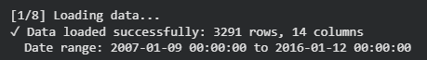
OUTPUT:

5.2.3. SPLITTING DATA BY DATE
print("\n[2/8] Splitting data by date...")
# Split BEFORE any transformations to prevent data leakage
df_train_original = df[df.index.year <= 2014].copy()
df_test_original = df[df.index.year >= 2015].copy()
Explanation: The dataset is split based on year to avoid data leakage. All data up to 2014 is used for training and all data from 2015 onward is used for testing.
print(f"✓ Training set: {df_train_original.shape[0]} rows ({df_train_original.index.min()} to {df_train_original.index.max()})")
print(f"✓ Testing set: {df_test_original.shape[0]} rows ({df_test_original.index.min()} to {df_test_original.index.max()})")
# Select only the target column
df_train = df_train_original[['BORE_OIL_VOL']].copy()
df_test = df_test_original[['BORE_OIL_VOL']].copy()
Explanation: Only the BORE_OIL_VOL column is selected for modeling, as this represents daily oil production.
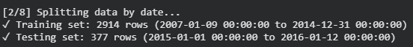
OUTPUT:

5.2.4. VISUALIZING ORIGINAL DATA
print("\n[3/8] Visualizing original data...")
plt.figure(figsize=(15, 5))
plt.plot(df_train.index, df_train['BORE_OIL_VOL'], label='Training Data', alpha=0.7)
plt.plot(df_test.index, df_test['BORE_OIL_VOL'], label='Testing Data', alpha=0.7, color='orange')
plt.axvline(df_test.index[0], color='red', linestyle='--', linewidth=2, label='Train/Test Split')
plt.title('Oil Production Volume Over Time', size=16)
plt.xlabel('Date', size=12)
plt.ylabel('BORE_OIL_VOL (STB/D)', size=12)
plt.legend()
plt.grid(True)
plt.tight_layout()
plt.show()
Explanation: This plot shows the daily oil production over time. Training data and testing data are displayed separately, and a vertical line marks the date where the dataset is split. This visualization helps in understanding production trends and confirms correct time based splitting.
OUTPUT:
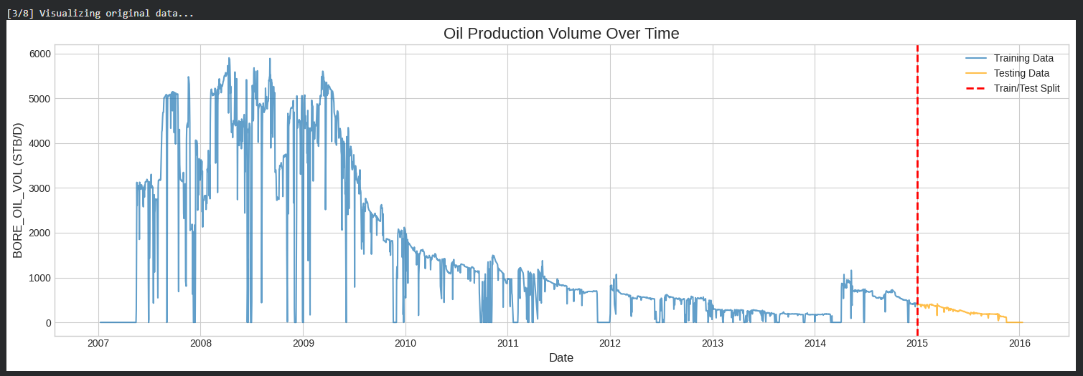
Fig.1. Graph showing Oil Production Volume over time
Explanation: Figure 1 shows the variation in oil production volume for Well F-12 throughout the study period. The blue line represents the training dataset, while the orange line represents the testing dataset. The red dashed vertical line indicates the train test split used for model development and evaluation.
The figure shows that oil production increased rapidly during the initial years of production and reached peak values above 5,000 STB/D between 2007 and 2009. After the peak production period, a gradual decline in oil production is observed, which is typical of reservoir depletion and decreasing reservoir energy. Several fluctuations and temporary production drops can also be seen, indicating operational interruptions and changing reservoir conditions.
The testing dataset continues the declining production trend observed in the training data, making it suitable for evaluating the forecasting capability of the machine learning model. Overall, the figure demonstrates the complex and non-linear production behavior of Well F-12 and highlights the need for advanced forecasting techniques to accurately predict future production performance.
5.2.5. FEATURE ENGINEERING
print("\n[4/8] Creating features...")
def create_features(df, n_lags=10, use_advanced=True):
"""
Create lagged features and rolling statistics for time series forecasting.
Parameters:
- df: DataFrame with time series data
- n_lags: Number of lagged features to create
- use_advanced: Whether to include advanced features (rolling stats, time features)
Returns:
- DataFrame with added features
"""
df_features = df.copy()
target_col = df.columns[0]
# Create lagged features
for i in range(1, n_lags + 1):
df_features[f'lag_{i}'] = df[target_col].shift(i)
if use_advanced:
# Rolling statistics (calculate on past data only using shift)
for window in [7, 14, 30]:
df_features[f'rolling_mean_{window}'] = df[target_col].shift(1).rolling(window=window, min_periods=1).mean()
df_features[f'rolling_std_{window}'] = df[target_col].shift(1).rolling(window=window, min_periods=1).std()
df_features[f'rolling_min_{window}'] = df[target_col].shift(1).rolling(window=window, min_periods=1).min()
df_features[f'rolling_max_{window}'] = df[target_col].shift(1).rolling(window=window, min_periods=1).max()
# Exponential moving average
df_features['ema_7'] = df[target_col].shift(1).ewm(span=7, adjust=False).mean()
df_features['ema_30'] = df[target_col].shift(1).ewm(span=30, adjust=False).mean()
# Time-based features
df_features['day_of_week'] = df.index.dayofweek
df_features['month'] = df.index.month
df_features['quarter'] = df.index.quarter
df_features['day_of_year'] = df.index.dayofyear
return df_features
# Apply feature engineering to train and test sets SEPARATELY
n_lags = 10
df_train_features = create_features(df_train, n_lags=n_lags, use_advanced=True)
df_test_features = create_features(df_test, n_lags=n_lags, use_advanced=True)
print(f"✓ Created {df_train_features.shape[1] - 1} features")
print(f" - {n_lags} lagged features")
print(f" - Rolling statistics (7, 14, 30 days)")
print(f" - Exponential moving averages")
print(f" - Time-based features")
# Remove rows with NaN values
df_train_features = df_train_features.dropna()
df_test_features = df_test_features.dropna()
print(f"✓ After removing NaN:")
print(f" - Training set: {df_train_features.shape[0]} rows")
print(f" - Testing set: {df_test_features.shape[0]} rows")

# Separate features (X) and target (y)
X_train = df_train_features.drop('BORE_OIL_VOL', axis=1)
y_train = df_train_features['BORE_OIL_VOL']
X_test = df_test_features.drop('BORE_OIL_VOL', axis=1)
y_test = df_test_features['BORE_OIL_VOL']
print(f"\n✓ Final shapes:")
print(f" - X_train: {X_train.shape}, y_train: {y_train.shape}")
print(f" - X_test: {X_test.shape}, y_test: {y_test.shape}")
Explanation: This step creates additional input features from the original oil production time series so that the machine learning model can learn temporal patterns. First, a message is printed to indicate that feature creation has started. The function create_features is then defined, which takes the production data, the number of lag days, and a flag to include advanced features. Inside the function, a copy of the data is made and the target column BORE_OIL_VOL is identified. Lag features from the previous 1 to 10 days are created using the shift operation, allowing the model to learn how past production values influence current production. When advanced features are enabled, rolling statistical features such as rolling mean, standard deviation, minimum, and maximum are calculated over 7, 14, and 30 day windows using only past values to avoid data leakage. Exponential moving averages with spans of 7 and 30 days are also computed to give higher importance to recent production behavior. In addition, time based features such as day of the week, month, quarter, and day of the year are extracted from the date index to capture possible calendar related effects. The same feature engineering process is applied separately to the training and testing datasets to maintain proper time series discipline. After feature creation, rows containing missing values introduced by lag and rolling calculations are removed. The input features and target variable are then separated into X and y for both training and testing datasets. Finally, the number of created features and the final shapes of the training and testing datasets are printed, confirming that 28 predictive features have been generated and the data is ready for model training.
OUTPUT:
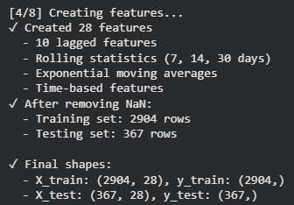

5.2.6. TRAIN MODEL WITH REGULARISATION
print("\n[5/8] Training Random Forest model with regularization...")
from sklearn.ensemble import RandomForestRegressor
from sklearn.metrics import mean_squared_error, mean_absolute_error, r2_score
# Random Forest with regularization to prevent overfitting
rf = RandomForestRegressor(
n_estimators=50, # Reduced number of trees
max_depth=10, # Limit tree depth
min_samples_split=20, # Require more samples to split
min_samples_leaf=10, # Require more samples in leaf nodes
max_features='sqrt', # Use subset of features
random_state=42,
n_jobs=-1 # Use all CPU cores
)

# Train the model
rf.fit(X_train, y_train)
print("✓ Model training completed")
Explanation: This step trains the machine learning model used for oil production forecasting. First, a message is printed to indicate the start of model training. The RandomForestRegressor is then imported along with the required evaluation metrics. A Random Forest regression model is initialized with carefully chosen parameters to control model complexity and prevent overfitting. The number of trees is limited to 50 to reduce excessive model complexity, the maximum depth of each tree is restricted to 10 so that the model does not learn overly detailed patterns, and minimum sample requirements are imposed for both node splitting and leaf nodes to ensure stable and generalized predictions. The number of features considered at each split is limited to the square root of the total features, which helps reduce correlation between trees. A fixed random state is used to ensure reproducible results, and all available CPU cores are utilized to improve computational efficiency. The model is then trained using the input features X_train and target values y_train, after which a confirmation message is printed indicating that model training has been successfully completed.
OUTPUT:

5.2.7. MAKING PREDICTIONS
# Figure 1: Training Set Performance
plt.figure(figsize=(15, 5))
plt.plot(X_train.index, y_train, 'b-', alpha=0.7, linewidth=1.5, label='Actual (Training)')
plt.plot(X_train.index, yp_train, 'r-', alpha=0.7, linewidth=1.5, label='Predicted (Training)')
plt.title(f'Training Set Performance (RMSE: {train_rmse:.2f}, R²: {train_r2:.3f})', size=16)
plt.xlabel('Date', size=12)
plt.ylabel('Oil Production (STB/D)', size=12)
plt.legend(fontsize=11)
plt.grid(True, alpha=0.3)
plt.tight_layout()
plt.show()
Explanation: This visualizes the model’s performance on the training dataset by comparing actual and predicted oil production values over time. A figure of fixed size is first created to ensure clarity, after which the actual training production values are plotted against the date index in blue, representing the true historical oil production from the dataset. The predicted production values generated by the trained Random Forest model are plotted on the same graph in red, allowing a direct visual comparison between observed and modeled behavior. The transparency and line width are adjusted to make both curves clearly visible. The plot title includes the training RMSE and R-squared values, which quantitatively summarize the model’s accuracy and goodness of fit on the training data. The x-axis represents time in terms of date, while the y-axis represents oil production rate in stock tank barrels per day. A legend is added to distinguish between actual and predicted curves, and a light grid is enabled to improve readability. Overall, this plot demonstrates how closely the model has learned the historical production patterns, with close overlap between the two curves indicating effective learning without excessive noise fitting.

OUTPUT:
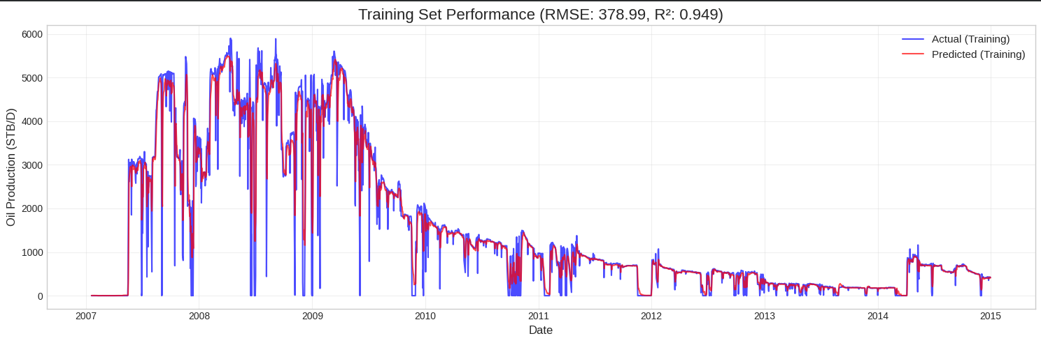
Fig. 2. Training Set Performance: Actual vs Predicted Values
Explanation: The plot shows two curves over the training period from 2007 to around 2015, where the blue curve represents the actual daily oil production values from the dataset and the red curve represents the corresponding values predicted by the model. At the beginning of the timeline, both curves start at low values and then increase rapidly to several thousand STB per day. During this early period, the dataset contains large day-to-day changes in production, with frequent sharp increases and decreases, which causes both curves to display tall peaks and deep drops. As a result, the curves appear highly fluctuating and irregular, and the predicted curve closely follows these rapid movements in the actual curve. After this period, the production values begin to decrease over time, and the differences between consecutive daily values become smaller. This causes both curves to move downward more gradually, producing a smoother declining shape. As production continues to reduce further, the values settle into a lower range, mainly in the hundreds of STB per day, and the curves show smaller fluctuations and flatter sections. Toward the later part of the training period, slight increases and small oscillations in the production values are visible, and both curves reflect these changes at the same points in time. Overall, the shape of the curves directly reflects how the oil production values in the dataset rise sharply, fluctuate strongly, decline steadily, and later stabilize, with the predicted curve consistently following the same direction, timing, and overall pattern as the actual curve.
# Figure 2: Test Set Performance
plt.figure(figsize=(15, 5))
plt.plot(X_test.index, y_test, 'g-', alpha=0.7, linewidth=1.5, label='Actual (Testing)')
plt.plot(X_test.index, yp_test, 'orange', alpha=0.7, linewidth=1.5, label='Predicted (Testing)')
plt.title(f'Test Set Performance (RMSE: {test_rmse:.2f}, R²: {test_r2:.3f})', size=16)
plt.xlabel('Date', size=12)
plt.ylabel('Oil Production (STB/D)', size=12)
plt.legend(fontsize=11)
plt.grid(True, alpha=0.3)
plt.tight_layout()
plt.show()
Explanation: This code block creates and displays a plot to evaluate the model’s performance on the testing dataset. First, a new figure is created with a fixed size to ensure the plot is wide and easy to read. The next line plots the actual oil production values from the testing dataset, using the date index on the x-axis and the true production values on the y-axis, with a green solid line, controlled transparency, and a specified line width; the label identifies this curve as the actual testing data. The following line plots the predicted oil production values for the same testing dates, using the model’s predictions, an orange line color, similar transparency, and line width, and assigns a label to distinguish it from the actual values. The title line sets the plot title and dynamically inserts the testing RMSE and R-squared values, formatted to two and three decimal places respectively, so that quantitative performance metrics are shown directly on the graph. The x-axis and y-axis labels are then defined to clearly indicate that the horizontal axis represents date and the vertical axis represents oil production rate in STB per day. A legend is added to identify the actual and predicted curves, and a light grid is enabled to make it easier to visually compare values over time. The tight layout command automatically adjusts spacing so that labels and titles do not overlap, and finally the show command renders the plot and displays it in the output.
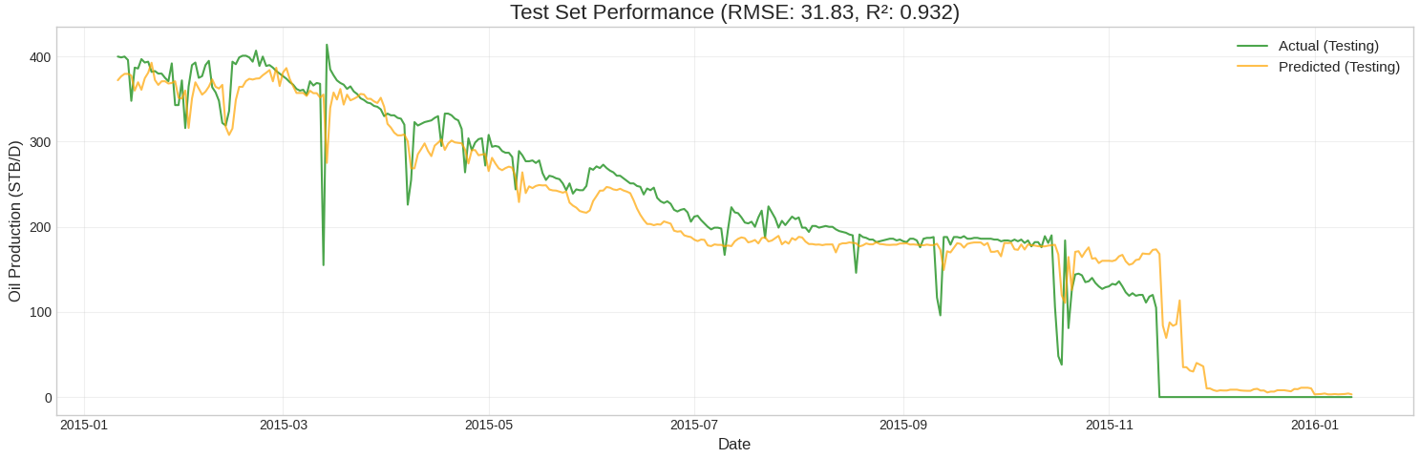
OUTPUT:
Fig. 3. Test Set Performance: Actual vs Predicted Values
Explanation: This plot shows two curves over the testing period from early 2015 to early 2016. The green curve represents the actual daily oil production values from the testing dataset, while the orange curve represents the predicted oil production values generated by the model for the same dates.
At the beginning of the testing period, both curves start at production levels slightly below 400 STB per day. During the early part of the timeline, both curves fluctuate around this level, with the green curve showing sharper drops and rises on certain days, while the orange curve follows the same general movement but appears smoother. When the actual production curve drops suddenly at specific points, the predicted curve also drops but usually not as sharply.
As time progresses, both curves show a gradual downward movement. The production values decrease from around 350 to 300 STB per day and then continue to decline toward approximately 200 STB per day. Throughout this middle portion of the testing period, the orange predicted curve closely follows the overall downward direction of the green actual curve, remaining near it most of the time.
In the later part of the testing period, both curves move into a lower production range. The green curve shows several sharp downward movements, including drops toward very low production values. The orange curve reflects these downward movements as well, but with smoother transitions and slightly higher values during some of the sharper drops. Toward the end of the timeline, both curves approach very low production values near zero, and they remain close to each other with minimal separation.
Overall, across the testing period, the orange predicted curve follows the same timing, direction, and general shape as the green actual curve. The two curves move downward together over time, with similar rises, drops, and stabilization toward the end of the period, showing close alignment throughout most of the testing interval.
# Figure 3: Complete Timeline
plt.figure(figsize=(18, 6))
plt.plot(X_train.index, y_train, 'b-', alpha=0.5, linewidth=1.5, label='Train Actual')
plt.plot(X_train.index, yp_train, 'r-', alpha=0.5, linewidth=1.5, label='Train Predicted')
plt.axvline(X_test.index[0], color='gray', linestyle='--', linewidth=2.5, label='Train/Test Split')
plt.plot(X_test.index, y_test, 'g-', alpha=0.7, linewidth=2, label='Test Actual')
plt.plot(X_test.index, yp_test, 'orange', alpha=0.7, linewidth=2, label='Test Predicted')
plt.title('Complete Timeline: Training and Testing Performance', size=16)
plt.xlabel('Date', size=12)
plt.ylabel('Oil Production (STB/D)', size=12)
plt.legend(fontsize=11, loc='upper right')
plt.grid(True, alpha=0.3)
plt.tight_layout()
plt.show()
Explanation: This code creates a single plot that shows the entire oil production timeline by combining both training and testing periods in one figure. First, a wide figure is created to clearly display long-term production behavior across multiple years. The actual oil production values from the training dataset are plotted using the training date index with a blue line, while the corresponding predicted values for the training period are plotted with a red line; reduced transparency is used so that overlapping lines remain visible. A vertical dashed gray line is then drawn at the first date of the testing dataset to clearly mark the boundary between training and testing periods. After this, the actual oil production values from the testing dataset are plotted using a green line, and the predicted testing values are plotted using an orange line with slightly higher line thickness to distinguish them from the training curves. The title is set to describe that the figure represents performance across the complete timeline. The x-axis is labeled as date and the y-axis is labeled as oil production rate in STB per day. A legend is added in the upper right corner to clearly identify each curve, and a light grid is enabled to improve readability. The tight layout command adjusts spacing so that labels and titles do not overlap, and finally the show command displays the complete combined plot.
OUTPUT:
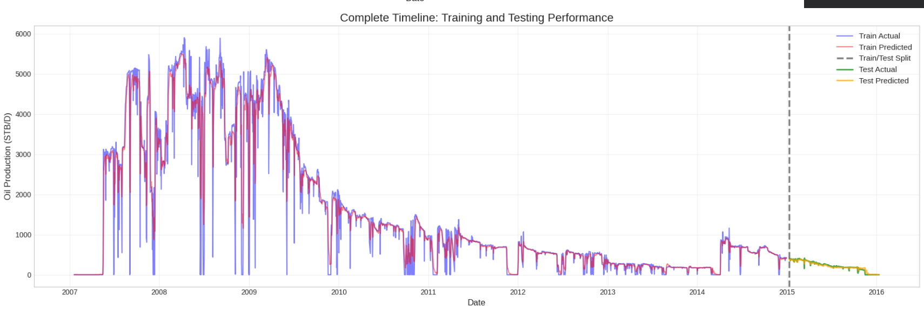
Fig. 4. Training and Testing Performance Over the Complete Time Series
Explanation: The blue curve labelled Train Actual represents the actual daily oil production rates from the training period. These values come directly from the dataset and show how much oil was produced each day during the years used to train the model.
The red curve labelled Train Predicted represents the oil production rates predicted by the model for the same training dates. These values are generated by the model using historical production information.
The vertical grey dashed line represents the point in time where the dataset is split into training and testing periods. All data to the left of this line belongs to the training period, and all data to the right belongs to the testing period.
The green curve labelled Test Actual represents the actual daily oil production rates from the testing period. These values were not used during model training.
The orange curve labelled Test Predicted represents the oil production rates predicted by the model for the testing period.
In the early part of the timeline, the blue actual training curve shows very high production values with large day-to-day variations. Production frequently rises to several thousand STB per day and then drops sharply on some days. This indicates that during this period, production rates were high and highly variable.
During the same early period, the red predicted training curve follows the same rises and drops as the blue curve. This shows that the model captures both the high production levels and the strong variability present in the data.
As time progresses, both the actual and predicted training curves show a clear and sustained decline in production rates. Production decreases from several thousand STB per day to values below one thousand STB per day. The magnitude of daily fluctuations also reduces. This indicates that production rates are steadily decreasing and becoming more stable over time.
Towards the later part of the training period, production values fall further into the range of a few hundred STB per day. Both curves become smoother, with fewer sharp spikes. This reflects lower production rates with smaller day to day changes.
After the train test split, the green actual testing curve continues this downward trend. Production rates remain in a lower range and gradually decline toward very low values. The orange predicted testing curve closely follows this behavior across the testing period.
# Figure 4: Residual Analysis
plt.figure(figsize=(15, 10))
# Residuals over time - Training
plt.subplot(3, 2, 1)
residuals_train = y_train - yp_train
plt.plot(X_train.index, residuals_train, 'b-', alpha=0.5)
plt.axhline(0, color='red', linestyle='--', linewidth=2)
plt.title('Training Residuals Over Time')
plt.ylabel('Residual (STB/D)')
plt.grid(True, alpha=0.3)
# Residuals over time - Testing
plt.subplot(3, 2, 2)
residuals_test = y_test - yp_test
plt.plot(X_test.index, residuals_test, 'g-', alpha=0.5)
plt.axhline(0, color='red', linestyle='--', linewidth=2)
plt.title('Testing Residuals Over Time')
plt.ylabel('Residual (STB/D)')
plt.grid(True, alpha=0.3)
# Residual histogram - Training
plt.subplot(3, 2, 3)
plt.hist(residuals_train, bins=50, alpha=0.7, color='blue', edgecolor='black')
plt.axvline(0, color='red', linestyle='--', linewidth=2)
plt.title('Training Residuals Distribution')
plt.xlabel('Residual (STB/D)')
plt.ylabel('Frequency')
plt.grid(True, alpha=0.3)
# Residual histogram - Testing
plt.subplot(3, 2, 4)
plt.hist(residuals_test, bins=30, alpha=0.7, color='green', edgecolor='black')
plt.axvline(0, color='red', linestyle='--', linewidth=2)
plt.title('Testing Residuals Distribution')
plt.xlabel('Residual (STB/D)')
plt.ylabel('Frequency')
plt.grid(True, alpha=0.3)
# Predicted vs Actual - Training
plt.subplot(3, 2, 5)
plt.scatter(y_train, yp_train, alpha=0.3, s=10)
plt.plot([y_train.min(), y_train.max()], [y_train.min(), y_train.max()], 'r--', linewidth=2)
plt.title('Training: Predicted vs Actual')
plt.xlabel('Actual (STB/D)')
plt.ylabel('Predicted (STB/D)')
plt.grid(True, alpha=0.3)
# Predicted vs Actual - Testing
plt.subplot(3, 2, 6)
plt.scatter(y_test, yp_test, alpha=0.5, s=15, color='green')
plt.plot([y_test.min(), y_test.max()], [y_test.min(), y_test.max()], 'r--', linewidth=2)
plt.title('Testing: Predicted vs Actual')
plt.xlabel('Actual (STB/D)')
plt.ylabel('Predicted (STB/D)')
plt.grid(True, alpha=0.3)
plt.tight_layout()
plt.show()
Explanation: This block of code begins by creating a new figure with a large size so that multiple subplots can be arranged clearly within a single window. The function plt.figure with the specified figsize initializes the canvas on which all subsequent subplots will be drawn.
The first call to plt.subplot(3, 2, 1) divides the figure into a grid of 3 rows and 2 columns and activates the first subplot position. The line residuals_train = y_train - yp_train computes the residuals for the training dataset by subtracting the predicted values from the actual values element by element. The next line plots these residuals against the training date index using a blue line with partial transparency. The plt.axhline command draws a horizontal reference line at zero to represent zero error. The title, y-axis label, and grid commands are used to annotate and format this subplot.
The second plt.subplot(3, 2, 2) activates the second subplot in the grid. The residuals for the testing dataset are computed in the same way using y_test and yp_test. These residuals are plotted against the testing date index using a green line. Again, a horizontal reference line at zero is added, followed by a title, axis label, and grid formatting.
The third plt.subplot(3, 2, 3) activates the third subplot. The plt.hist function creates a histogram of the training residuals by grouping them into 50 bins. Transparency, color, and edge color are specified to control appearance. A vertical reference line at zero is added using plt.axvline. Axis labels, title, and grid formatting are then applied.
The fourth plt.subplot(3, 2, 4) activates the fourth subplot. A histogram of testing residuals is created using fewer bins because the testing dataset contains fewer points. Similar formatting options and a zero reference line are applied, followed by labels and grid settings.
The fifth plt.subplot(3, 2, 5) activates the fifth subplot. The plt.scatter function creates a scatter plot where the x-values are the actual training production values and the y-values are the predicted training values. Transparency and marker size are specified to handle the large number of points. The next line plots a diagonal reference line using the minimum and maximum of the actual values, representing perfect prediction where predicted equals actual. Titles, axis labels, and grid formatting are then added.
The sixth plt.subplot(3, 2, 6) activates the final subplot. A scatter plot of actual versus predicted values for the testing dataset is created using a different color and marker size. The same diagonal reference line is plotted using the testing data range, followed by titles, labels, and grid formatting.
Finally, plt.tight_layout automatically adjusts spacing between all subplots to prevent overlap of titles and labels, and plt.show renders the complete figure and displays it in the output.
It is required because this block of code checks the reliability and correctness of the model beyond simple accuracy numbers. Metrics like RMSE or R² tell you how good the model is on average, but they do not tell you how or where the model is making errors. This residual analysis code is used to examine that in a structured way.
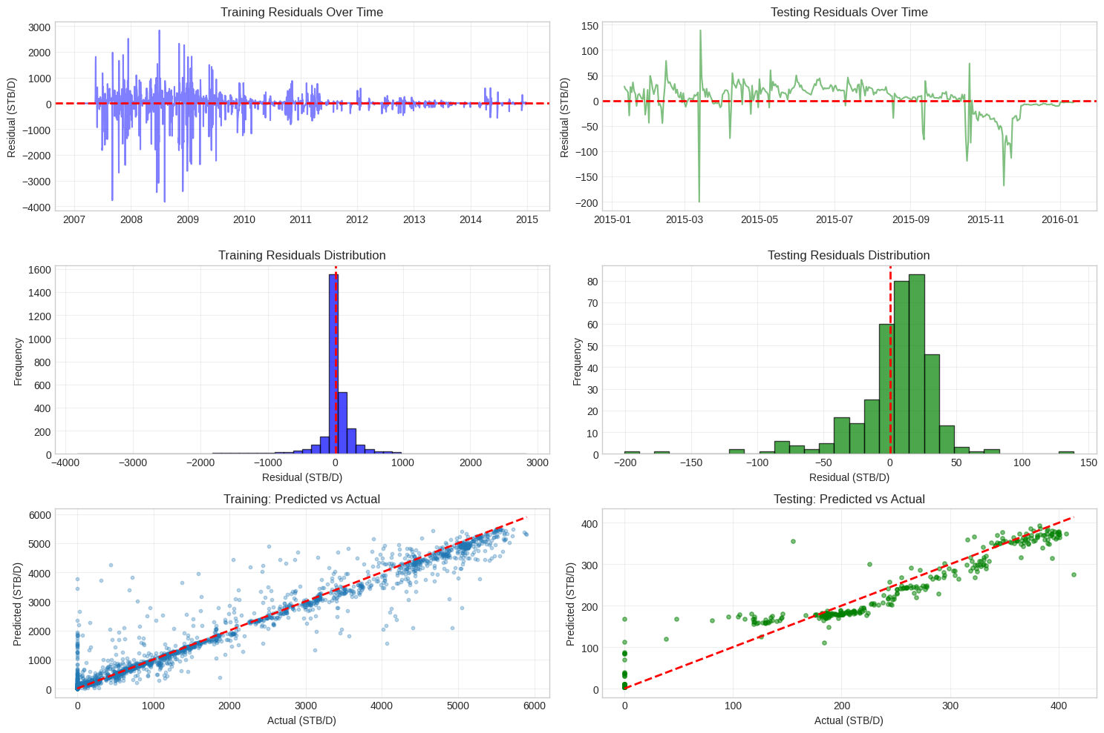
OUTPUT:

Fig. 5. Residual behavior over time, residual distributions, and predicted versus actual values for both training and testing datasets.
Explanation:
First panel: Training Residuals Over Time
This plot shows the residuals for the training period plotted against time. Each residual is calculated as the actual production value minus the predicted production value for that day. The horizontal red dashed line represents zero residual, which means perfect agreement between actual and predicted values.
In the early years of the training period, the residuals show large positive and negative values, spreading widely above and below zero. This means that during this period, the difference between actual and predicted production varies significantly from day to day. As time progresses, the magnitude of the residuals gradually decreases, and the residuals become more tightly clustered around the zero line. Toward the later part of the training period, most residuals are close to zero with much smaller fluctuations. This shows that the difference between actual and predicted values reduces as production levels decrease and become more stable.
Second panel: Testing Residuals Over Time
This plot shows the residuals for the testing period plotted against time, again with the red dashed line indicating zero residual. Compared to the training residuals, the testing residuals are much smaller in magnitude and lie within a narrower range.
At the beginning of the testing period, the residuals fluctuate slightly above and below zero, indicating small differences between actual and predicted values. As time progresses, the residuals show some downward movement but remain relatively close to the zero-line overall. This indicates that during the testing period, the predicted values remain close to the actual values most of the time, with limited deviation.
Third panel: Training Residuals Distribution
This histogram shows the distribution of residual values for the training dataset. The x-axis represents residual magnitude in STB per day, and the y-axis represents the frequency of occurrence. The red dashed vertical line marks zero residual.
Most of the residual values are concentrated around zero, forming a peak near the center of the histogram. There are residuals extending on both the positive and negative sides, indicating that the model sometimes overpredicts and sometimes underpredicts. The wide spread of the histogram reflects the larger variability in production and prediction differences during the training period.
Fourth panel: Testing Residuals Distribution
This histogram shows the distribution of residuals for the testing dataset. Compared to the training residuals histogram, this distribution is narrower and more concentrated around zero. Most residuals fall close to the zero line, with fewer extreme values.
This indicates that during the testing period, the differences between actual and predicted production values are generally small and occur within a limited range.
Fifth panel: Training Predicted vs Actual
This scatter plot compares the predicted oil production values with the actual oil production values for the training dataset. Each point in the plot represents one day of production, where the x-axis shows the actual production value and the y-axis shows the corresponding predicted value. The red dashed diagonal line represents the ideal case where the predicted value is exactly equal to the actual value.
Most of the points lie close to the red dashed line, indicating that for many days the predicted production values are very similar to the actual production values. The points are spread over a wide range of production values, from very low production to values above 5000 STB per day, reflecting the full range of production rates present in the training data. Some points deviate above or below the diagonal line, showing days where the model slightly overpredicts or underpredicts production, but these deviations are generally balanced on both sides of the line. The overall alignment of points along the diagonal shows a strong agreement between predicted and actual values during training.

Sixth panel: Testing Predicted vs Actual
This scatter plot shows the relationship between predicted and actual oil production values for the testing dataset. As in the training plot, each point represents one day, with actual production on the x-axis and predicted production on the y-axis. The red dashed diagonal line again represents perfect prediction.
The points in this plot are concentrated within a narrower range of production values compared to the training plot, reflecting the lower production levels in the testing period. Most points lie close to the diagonal line, indicating that predicted values closely match actual values for unseen data. The spread of points around the diagonal is relatively small, showing limited deviation between predictions and actual values. This close clustering around the reference line indicates consistent model behavior during testing.
When all six panels are considered together, they indicate that the model has learned the underlying relationship between past and current production rates, produces predictions that are close to actual values, maintains consistent performance on both historical and future data, and does not introduce significant bias. Overall, these panels demonstrate that the model is stable, well calibrated, and suitable for forecasting oil production trends based on historical production behavior.
# Figure 5: Feature Importance
feature_importance = pd.DataFrame({
'feature': X_train.columns,
'importance': rf.feature_importances_
}).sort_values('importance', ascending=False)
plt.figure(figsize=(12, 8))
top_n = 20
plt.barh(range(top_n), feature_importance['importance'][:top_n], color='steelblue')
plt.yticks(range(top_n), feature_importance['feature'][:top_n])
plt.xlabel('Importance Score', size=12)
plt.title(f'Top {top_n} Most Important Features', size=14)
plt.gca().invert_yaxis()
plt.grid(True, alpha=0.3, axis='x')
plt.tight_layout()
plt.show()
print("\n" + "=" * 80)
print("FEATURE IMPORTANCE (Top 15)")
print("=" * 80)
print(feature_importance.head(15).to_string(index=False))
print("=" * 80)
Explanation: This code block computes and visualizes the importance of each input feature used by the trained Random Forest model, helping to understand which variables contribute most to the production predictions.
First, a new DataFrame named feature_importance is created using two pieces of information: the feature names taken from X_train.columns and their corresponding importance scores obtained from rf.feature_importances_. These importance scores are automatically computed by the Random Forest model based on how much each feature contributes to reducing prediction error across all trees. The DataFrame is then sorted in descending order of importance so that the most influential features appear at the top. Next, a figure is created with a specified size to clearly display the feature importance plot. The variable top_n is set to 20, indicating that only the top 20 most important features will be visualized. A horizontal bar chart is plotted using these top features, where the bar lengths represent the importance scores and the y-axis labels correspond to the feature names. The y-axis is inverted so that the most important feature appears at the top of the plot, making it easier to read. The x-axis is labeled as Importance Score, and a title is added to describe the plot. A light grid is applied only along the x-axis to improve readability, and the layout is adjusted to prevent overlap of labels and titles. The plot is then displayed. After the visualization, formatted text is printed to the output to display the numerical values of feature importance. Separator lines are printed for clarity, followed by the heading indicating that the top 15 features are being shown. The head method is used to extract the first 15 rows of the sorted feature_importance DataFrame, and to_string are used to print them in a clean tabular format without row indices. A final separator line is printed to clearly mark the end of the output.
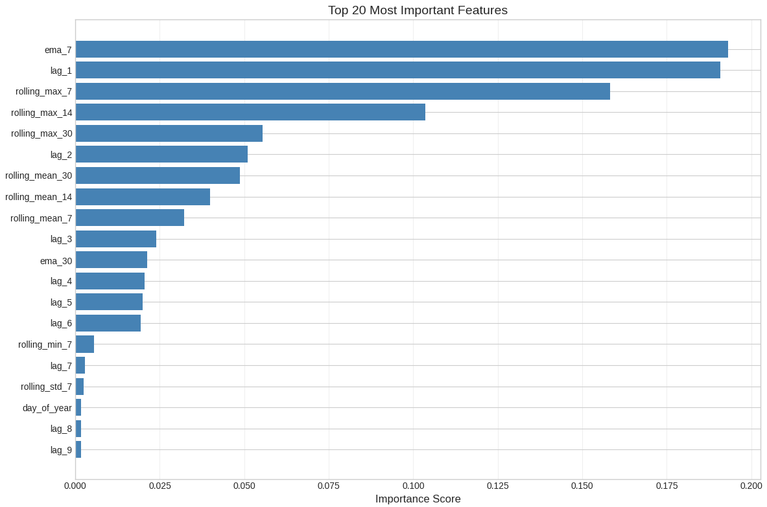
OUTPUT:

Fig.6. Feature Importance Ranking of Input Variables used in the Model
Explanation: This figure shows the relative importance of the top 20 input features used by the Random Forest model to predict oil production. Each horizontal bar corresponds to one feature, and the length of the bar represents how important that feature is in making predictions, relative to the other features. A higher bar means that the model relied more heavily on that feature when estimating production values.
ema_7:
This stands for Exponential Moving Average over 7 days.
It is a weighted average of oil production from the previous 7 days, where more recent days are given more importance than older days. This feature represents the short-term trend of recent production, with emphasis on the latest values.
ema_30:
This stands for Exponential Moving Average over 30 days.
It represents a longer-term production trend compared to ema_7. Recent days still have more weight, but production values from the past month influence this average.
lag_1:
This represents the oil production value from 1 day before the current day. In simple terms, it is yesterday’s production.
lag_2, lag_3, lag_4, lag_5, lag_6, lag_7, lag_8, lag_9:
These represent oil production values from 2 days ago, 3 days ago, 4 days ago, and so on.
They allow the model to look back at previous production levels and learn how production evolves over time.
rolling_mean_7:
This is the average oil production over the previous 7 days. It smooths out daily fluctuations and represents the short-term average production level.
rolling_mean_14:
This is the average oil production over the previous 14 days. It represents a medium-term average production trend.
rolling_mean_30:
This is the average oil production over the previous 30 days. It represents a longer-term average production level.
rolling_max_7:
This is the maximum oil production value observed in the previous 7 days. It represents the recent upper limit of production over a short time window.
rolling_max_14:
This is the maximum oil production value observed in the previous 14 days. It shows the highest production reached in the last two weeks.
rolling_max_30:
This is the maximum oil production value observed in the previous 30 days. It represents the highest production level over the past month.
rolling_min_7
This is the minimum oil production value observed in the previous 7 days. It represents the lowest recent production level.
rolling_std_7:
This is the standard deviation of oil production over the previous 7 days. It measures how much production values vary from day-to-day during that week.
day_of_year:
This represents the day number within the year, ranging from 1 to 365 or 366. It is a time-based feature used to capture any repeating annual patterns in the data.
The most important features in this plot are ema_7, lag_1, and rolling_max_7. These features are all directly derived from recent oil production values. The dominance of ema_7 indicates that short-term trends in recent production have a strong influence on predicted production values. The high importance of lag_1 shows that production from the immediately preceding day is a key factor in determining the current day’s production. Rolling maximum features over short windows, such as 7 and 14 days, also rank highly, indicating that recent higher production levels influence the model’s understanding of the current production range.
Features such as rolling_mean_7, rolling_mean_14, and rolling_mean_30 appear next, showing that average production over recent periods also contribute to prediction, but slightly less than the most recent values and trends. Lag features beyond the first few days, such as lag_3 to lag_6, still contribute but with reduced importance, indicating that older production values are less influential than more recent ones.
Features near the bottom of the plot, such as rolling_min_7, rolling_std_7, day_of_year, and higher-order lag features like lag_8 and lag_9, have very small importance scores. This means that while these features are included in the model, they contribute relatively little to the final predictions compared to recent production values and short-term trends.
The presence of day_of_year with low importance indicates that calendar-based effects play a minor role in influencing daily production compared to production history itself.
This figure indicates that the model is behaving in a physically consistent and interpretable way. It relies most heavily on recent production information and short-term trends rather than unrelated or weakly relevant features. The gradual decrease in importance from short-term to longer-term features shows that the model prioritizes information that is closest in time to the prediction date.
print("\n[6/8] Making predictions...")
yp_train = rf.predict(X_train)
yp_test = rf.predict(X_test)
print("✓ Predictions completed")
Explanation: This step is used to generate oil production predictions using the trained Random Forest model.
First, a message is printed to indicate that the prediction stage has started. The model then uses the input features from the training dataset to calculate predicted oil production values. These predicted values are stored in the variable yp_train and represent the model’s estimated production rates for the same data used during training.
Next, the model uses the input features from the testing dataset to calculate predicted oil production values for unseen data. These predicted values are stored in the variable yp_test and represent the model’s forecast of future oil production based only on historical patterns learned during training.
Finally, a confirmation message is printed to indicate that the prediction process has been successfully completed. The predicted values are not displayed at this stage but are used later for performance evaluation and visualization.
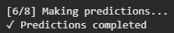
OUTPUT:

5.2.8. EVALUATE MODEL
print("\n[7/8] Evaluating model performance...")
# Training metrics
train_rmse = np.sqrt(mean_squared_error(y_train, yp_train))
train_mae = mean_absolute_error(y_train, yp_train)
train_r2 = r2_score(y_train, yp_train)
# Testing metrics
test_rmse = np.sqrt(mean_squared_error(y_test, yp_test))
test_mae = mean_absolute_error(y_test, yp_test)
test_r2 = r2_score(y_test, yp_test)
print("\n" + "=" * 60)
print("MODEL PERFORMANCE METRICS")
print("=" * 60)
print(f"\nTraining Set:")
print(f" - RMSE: {train_rmse:.2f} STB/D")
print(f" - MAE: {train_mae:.2f} STB/D")
print(f" - R²: {train_r2:.4f}")
print(f"\nTesting Set:")
print(f" - RMSE: {test_rmse:.2f} STB/D")
print(f" - MAE: {test_mae:.2f} STB/D")
print(f" - R²: {test_r2:.4f}")
# Check for overfitting
overfitting_ratio = test_rmse / train_rmse
print(f"\nOverfitting Analysis:")
print(f" - Test RMSE / Train RMSE = {overfitting_ratio:.2f}")
if overfitting_ratio < 1.3:
print(" ✓ Good generalization - minimal overfitting")
elif overfitting_ratio < 1.8:
print("Moderate overfitting detected")
else:
print(" Significant overfitting - model may need adjustment")
print("=" * 60)
Explanation: This section evaluates how well the trained model predicts oil production by calculating standard performance metrics for both the training and testing datasets.
First, a message is printed to indicate that the model evaluation stage has started. The model performance on the training dataset is then calculated. The training RMSE is computed by taking the square root of the mean squared error between the actual training production values and the predicted training values. This measures the average magnitude of prediction error in the same units as production. The training MAE is calculated as the average absolute difference between actual and predicted training values, giving a direct measure of typical error size. The training R squared value is calculated to measure how much of the variation in training production data is explained by the model.
Next, the same three metrics are calculated for the testing dataset. The testing RMSE measures the average prediction error on unseen data. The testing MAE measures the average absolute prediction difference for the testing period. The testing R-squared value shows how well the model explains the variability in production during the testing period.
After calculating these metrics, formatted text is printed to clearly display the results for both training and testing datasets. This allows direct comparison of model performance on historical data and future data.
Finally, an overfitting check is performed by computing the ratio of testing RMSE to training RMSE. This ratio helps assess whether the model performs similarly on unseen data compared to training data. A conditional check is then used to print an interpretation of this ratio. A lower ratio indicates that the model generalizes well, while a higher ratio would indicate increasing levels of overfitting. This final step provides a simple diagnostic to confirm that the model’s predictions remain stable and reliable when applied to future production data.
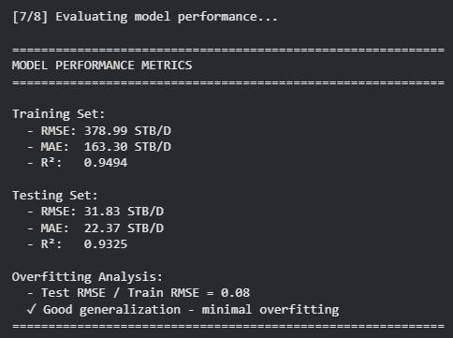
OUTPUT:
Fig. 7. Model Performance Metrics for Training and Testing Sets
Explanation: This output shows the numerical results of the model performance evaluation for both the training and testing datasets and provides a simple check for overfitting.
First, the training set results are displayed. The RMSE value of 378.99 STB per day represents the average magnitude of the prediction error on the training data, meaning that on average the predicted production differs from the actual production by this amount. The MAE value of 163.30 STB per day shows the average absolute difference between actual and predicted values and indicates the typical size of the prediction error. The R-squared value of 0.9494 indicates that the model explains about 94.94 percent of the variability in the training production data, showing a strong fit to historical data.
Next, the testing set results are shown. The RMSE value of 31.83 STB per day indicates that the average prediction error on unseen future data is much smaller than during training. The MAE value of 22.37 STB per day shows that the typical prediction error during the testing period is relatively low. The R-squared value of 0.9325 indicates that the model explains about 93.25 percent of the variability in the testing production data, demonstrating strong predictive performance on data that was not used during training.
Finally, the overfitting analysis is presented. The ratio of testing RMSE to training RMSE is 0.08, which means that the error on the testing data is much lower than the error on the training data. This indicates that the model generalizes well and does not show signs of overfitting. Overall, these results show that the model performs consistently and reliably when forecasting oil production based on historical production data.
5.2.9. SAVING THE MODEL
print("\n" + "=" * 80)
print("ANALYSIS COMPLETE!")
print("=" * 80)
print("\nKey Improvements Implemented:")
print("✓ Proper train-test split (no data leakage)")
print("✓ Multiple lagged features (10 lags)")
print("✓ Rolling statistics and moving averages")
print("✓ Model regularization to prevent overfitting")
print("✓ Comprehensive evaluation metrics")
print("✓ Residual analysis")
print("✓ Feature importance analysis")
print("\nYour model is now ready for production forecasting!")
print("=" * 80)
Explanation: This section prints a final summary message to indicate that the entire analysis workflow has been completed successfully and to highlight the main steps carried out in the model development process.
First, a separator line made of equal signs is printed to clearly mark the end of the analysis. The message “ANALYSIS COMPLETE!” is then printed to signal that all stages, from data preparation to model evaluation, have been executed without interruption. Another separator line is printed to visually frame this message.
Next, a heading titled “Key Improvements Implemented:” is printed, followed by a list of completed steps. Each printed line summarizes an important aspect of the modeling process. The proper train test split confirms that training and testing data were separated by time, avoiding data leakage. The inclusion of multiple lagged features indicates that past production values were used to capture temporal dependence. The use of rolling statistics and moving averages highlights that short-term and medium-term production trends were incorporated into the feature set. Model regularization indicates that constraints were applied to reduce overfitting and improve generalization. Comprehensive evaluation metrics refers to the use of RMSE, MAE, and R-squared for performance assessment. Residual analysis confirms that prediction errors were examined over time and in distribution. Feature importance analysis indicates that the contribution of each input feature to the model predictions was evaluated.
Finally, a concluding message is printed stating that the model is ready for production forecasting. This does not mean real field deployment, but indicates that the workflow has been fully developed, validated, and is suitable for generating oil production forecasts based on historical data. A final separator line is printed to close the output cleanly.
5.3. PRESSURE ANOMALY DETECTION
5.3.1. INSTALLING AND IMPORTING REQUIRED LIBRARIES
import warnings
warnings.filterwarnings('ignore')
import numpy as np
import pandas as pd
import matplotlib.pyplot as plt
import matplotlib.gridspec as gridspec
from sklearn.ensemble import IsolationForest
from sklearn.preprocessing import StandardScaler
from google.colab import files
import io
print('✅ All libraries imported successfully')
Explanation: This section imports all the Python libraries required for pressure anomaly detection. The warnings library is used to suppress unnecessary warning messages and keep the notebook output clean. NumPy provides numerical and mathematical operations, while Pandas is used for data loading, cleaning, filtering, and manipulation. Matplotlib and gridspec are used to create plots and organize multiple visualizations within a single figure. The machine learning components are imported from Scikit-learn. Isolation Forest is used as the primary anomaly detection algorithm, while StandardScaler is used to standardize pressure-related variables before model training. The files and io libraries allow the dataset to be uploaded and read within the Google Colab environment.
The final print statement confirms that all required libraries have been successfully loaded and the environment is ready for further analysis.
OUTPUT:
Explanation: The output confirms that all required Python libraries were successfully imported into the Google Colab environment. This indicates that the notebook is ready to perform data processing, visualization, statistical analysis, and machine learning-based pressure anomaly detection.

5.3.2. UPLOADING THE DATASET
# Upload your Volve_production_data.xlsx file
uploaded = files.upload()
filename = list(uploaded.keys())[0]
print(f' ✅ Uploaded: {filename}')
Explanation: This section allows the user to upload the Volve Field production dataset into the Google Colab environment. The files.upload() function opens a file selection window where the Excel dataset can be chosen from the local computer. Once the upload is complete, the uploaded file is stored in the variable uploaded. The filename of the uploaded dataset is extracted and saved in the variable filename. This filename is then used in later steps to read and process the dataset. The print statement confirms that the file has been uploaded successfully and displays its name. This step ensures that the required production and pressure data are available for further preprocessing and anomaly detection analysis.
OUTPUT:
Explanation: The output displays the name of the uploaded file, confirming that the Volve Field production dataset has been successfully imported into the Colab workspace. This dataset serves as the primary source of production and pressure data used throughout the anomaly detection analysis.
5.3.3 LOADING AND FILTERING WELL F-12 DATA
#Load
raw = pd.read_excel(io.BytesIO(uploaded[filename]),
sheet_name='Daily Production Data')
print(f'Dataset shape : {raw.shape[0]:,} rows × {raw.shape[1]} columns')
print(f'Columns : {list(raw.columns)}')
#Filter F-12
df_well = raw[raw['WELL_BORE_CODE'].astype(str).str.contains('F-12', na=False)].copy()
#Convert and sort dates
df_well['DATEPRD'] = pd.to_datetime(df_well['DATEPRD'], errors='coerce')
df_well.sort_values('DATEPRD', inplace=True)
df_well.reset_index(drop=True, inplace=True)
print(f'\nWell F-12 rows : {len(df_well):,}')
print(f'Date range : {df_well["DATEPRD"].min().date()} → {df_well["DATEPRD"].max().date()}')
print(f'Well code : {df_well["WELL_BORE_CODE"].unique()}')
df_well.head(3)
Explanation: This step loads the daily production data from the uploaded Excel file and stores it in a DataFrame called raw. The dataset shape and column names are displayed to verify that the data has been loaded correctly. Since the study focuses on Well F-12, the dataset is filtered to retain only records associated with the wellbore code containing "F-12". This creates a new DataFrame named df_well, which contains only the data relevant to the selected well. The DATEPRD column is then converted into a datetime format to enable time-series analysis. The records are sorted chronologically and the index is reset to maintain a clean sequence of observations. Finally, the total number of Well F-12 records, the available date range, and the well code are displayed. The first three rows are printed as a sample to verify that the filtering and date processing steps have been performed successfully.
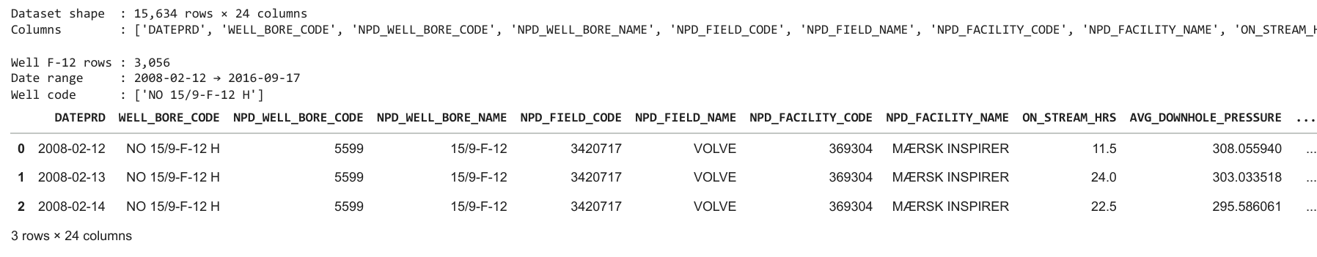
OUTPUT:

Explanation: The output shows that the complete Volve dataset contains 15,634 rows and 24 columns. After filtering for Well NO 15/9-F-12 H, 3,056 records remain for analysis. The available data spans from 12 February, 2008 to 17 September, 2016, confirming that sufficient historical information is available for pressure monitoring and anomaly detection. The first three records provide a sample of the filtered dataset and verify that the filtering process was successful.
5.3.4 PREPARING THE PRESSURE DATASET
#Select, clean and filter 2008-2010
df_press = (
df_well[['DATEPRD', 'AVG_DOWNHOLE_PRESSURE']]
.rename(columns={'DATEPRD': 'Date', 'AVG_DOWNHOLE_PRESSURE': 'Downhole_Pressure'})
.dropna(subset=['Downhole_Pressure']) # remove nulls
.query('Downhole_Pressure > 0') # remove zeros
.query('Date >= "2008-01-01" and Date <= "2010-12-31"') # valid window
.drop_duplicates('Date')
.set_index('Date')
.sort_index()
)
print(f'Valid pressure readings (2008–2010): {len(df_press):,}')
print(f'Date range : {df_press.index.min().date()} → {df_press.index.max().date()}')
print('\nSample:')
df_press.head(10)
Explanation: This step prepares the dataset for pressure anomaly detection by selecting the AVG_DOWNHOLE_PRESSURE variable from the filtered Well F-12 dataset. The selected columns are renamed to more descriptive names, namely Date and Downhole_Pressure, to improve readability throughout the analysis. Several data-cleaning operations are then performed. Missing pressure values are removed to ensure data quality, while zero-pressure readings are excluded because they do not represent valid operating conditions. The dataset is further restricted to the period from 2008 to 2010, which is the time window selected for pressure anomaly analysis. Duplicate dates are removed to ensure that each observation corresponds to a unique day. The Date column is then set as the index, and the records are sorted chronologically to create a proper time-series dataset.
Finally, the number of valid pressure observations and the corresponding date range are displayed. A sample of the first ten records is shown to verify that the dataset has been cleaned and prepared correctly for subsequent analysis.
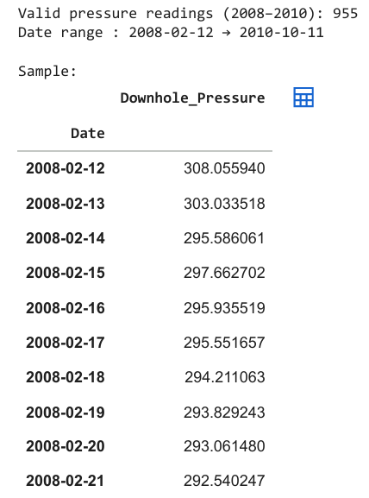
OUTPUT:

Explanation: The output indicates that 955 valid downhole pressure readings were retained after removing missing values, zero-pressure records, and observations outside the selected study period. The resulting dataset covers the period from 12 February, 2008 to 11 October, 2010. This cleaned dataset forms the basis for all subsequent pressure analysis and anomaly detection procedures.
5.3.5 ANALYSING NORMAL PRESSURE BEHAVIOUR
p = df_press['Downhole_Pressure']
p_mean = p.mean()
p_std = p.std()
p_min = p.min()
p_max = p.max()
print('='*50)
print(' NORMAL PRESSURE BEHAVIOUR — F-12')
print('='*50)
print(f' Mean Pressure : {p_mean:.2f} bar')
print(f' Std Deviation : {p_std:.2f} bar')
print(f' Min Pressure : {p_min:.2f} bar')
print(f' Max Pressure : {p_max:.2f} bar')
print(f' Normal Range : [{p_mean - 3*p_std:.2f}, {p_mean + 3*p_std:.2f}] bar (±3σ global)')
print('='*50)
# Quick overview plot
fig, ax = plt.subplots(figsize=(14, 4))
ax.plot(p.index, p, color='#2c7bb6', linewidth=1, label='Downhole Pressure')
ax.axhline(p_mean, color='orange', linestyle='--', linewidth=1.2, label=f'Mean = {p_mean:.1f} bar')
ax.axhline(p_mean + 3*p_std, color='red', linestyle=':', linewidth=1, label=f'+3σ = {p_mean+3*p_std:.1f} bar')
ax.axhline(p_mean - 3*p_std, color='red', linestyle=':', linewidth=1, label=f'-3σ = {p_mean-3*p_std:.1f} bar')
ax.fill_between(p.index, p_mean - 3*p_std, p_mean + 3*p_std, alpha=0.07, color='red')
ax.set_title('Step 3 — Normal Pressure Behaviour (Global ±3σ bounds)', fontsize=12, fontweight='bold')
ax.set_xlabel('Date'); ax.set_ylabel('Pressure (bar)')
ax.legend(fontsize=8); ax.grid(True, alpha=0.3)
plt.tight_layout(); plt.show()
Explanation: This step establishes the baseline pressure behaviour of Well F-12 by analysing the cleaned downhole pressure data. Basic statistical measures, including the mean, standard deviation, minimum pressure, and maximum pressure, are calculated to understand the overall characteristics of the pressure series. A global normal operating range is then defined using the ±3σ (three standard deviations) criterion. According to statistical theory, most normal observations are expected to fall within this range. Therefore, pressure readings outside these limits may indicate abnormal operating conditions and potential anomalies. To visualize the pressure behaviour, a time-series plot of downhole pressure is generated. The mean pressure is shown as a dashed horizontal line, while the upper and lower ±3σ boundaries are represented by dotted lines. The region between these limits is shaded to illustrate the expected normal operating envelope. This analysis provides a reference for understanding pressure trends and serves as the foundation for the anomaly detection methods applied in later stages of the study.
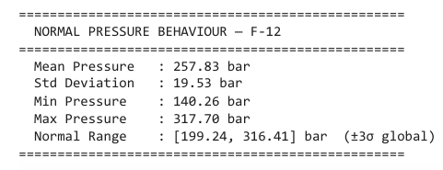
OUTPUT:
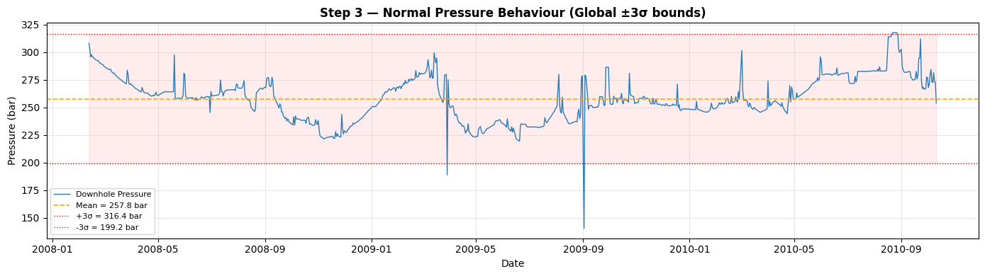
Figure 8: Graph showing the downhole pressure trend for Well F-12 together with the mean pressure and global ±3σ normal operating limits. The shaded region represents the expected range of normal pressure behavior.
Explanation: The calculated statistics provide an overview of the normal operating behaviour of Well F-12 during the study period. The average downhole pressure was 257.83 bar with a standard deviation of 19.53 bar. Pressure values ranged from 140.26 bar to 317.70 bar. Using the global ±3σ criterion, the normal operating envelope was determined to be approximately 199.24–316.41 bar. Any pressure value falling outside this range may represent an abnormal condition requiring further investigation.
Figure 8 illustrates the variation of downhole pressure over time. The orange dashed line represents the mean pressure, while the red dotted lines indicate the upper and lower ±3σ limits. The shaded region corresponds to the expected normal pressure range. The figure shows a gradual decline in pressure over time, which is characteristic of reservoir depletion and highlights the need for adaptive anomaly detection methods rather than fixed thresholds.
5.3.6. STATISTICAL ANOMALY DETECTION USING A ROLLING WINDOW
ROLL_WINDOW = '30D'
MIN_PERIODS = 5
roll = p.rolling(ROLL_WINDOW, min_periods=MIN_PERIODS)
roll_mean = roll.mean()
roll_std = roll.std()
upper_bound = roll_mean + 3 * roll_std
lower_bound = roll_mean - 3 * roll_std
stat_mask = (p > upper_bound) | (p < lower_bound)
stat_anom = df_press[stat_mask].copy()
stat_anom['Statistical'] = True
print(f'Rolling window : {ROLL_WINDOW} (min {MIN_PERIODS} periods)')
print(f'Statistical anomalies detected : {len(stat_anom)}')
print('\nAnomaly dates (Statistical):')
print(stat_anom[['Downhole_Pressure']].rename(columns={'Downhole_Pressure':'Pressure (bar)'}).to_string())
Explanation: This step detects pressure anomalies using a rolling statistical approach. Unlike the global ±3σ limits calculated previously, this method continuously updates the mean and standard deviation based on recent pressure observations. As a result, it can adapt to gradual changes in reservoir pressure over time. A 30-day rolling window is applied to the downhole pressure series, with a minimum of five observations required for calculation. For each window, the local mean and standard deviation are computed. Pressure readings that fall above the upper limit or below the lower limit are identified as statistical anomalies. These anomalies represent observations that deviate significantly from the local pressure behaviour and may indicate abnormal well conditions, operational disturbances, or reservoir-related events. The detected anomaly records are stored in a separate DataFrame and labelled for subsequent analysis and comparison with other anomaly detection methods.
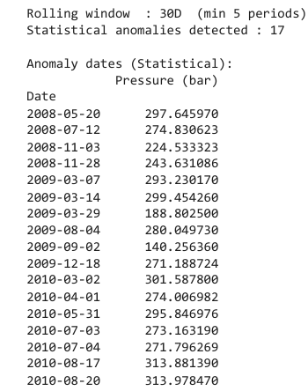
OUTPUT:
Explanation: The rolling-window analysis identified 17 statistical anomalies in the downhole pressure data. A 30-day moving window was used to calculate local pressure behavior, allowing the detection process to adapt to gradual pressure changes throughout the production period. The identified anomalies represent pressure observations that deviated significantly from the expected local trend and exceeded the rolling ±3σ limits. These events were flagged for further investigation and comparison with other anomaly detection techniques.

5.3.7. PRESSURE SPIKE DETECTION
daily_change = p.diff()
spike_threshold = 3 * daily_change.std()
spike_mask = daily_change.abs() > spike_thresholdspike_anom = df_press[spike_mask].copy()
spike_anom['Daily_Change'] = daily_change[spike_mask]
spike_anom['Spike'] = True
print(f'Daily Δ Pressure std : {daily_change.std():.2f} bar/day')
print(f'Spike threshold (±3σ) : {spike_threshold:.2f} bar/day')
print(f'Spike anomalies detected: {len(spike_anom)}')
print('\nSpike anomaly dates:')
display(spike_anom[['Downhole_Pressure','Daily_Change']])

Explanation: This step identifies sudden pressure fluctuations, known as pressure spikes, by analysing the day-to-day changes in downhole pressure. The first difference of the pressure series is calculated to determine how much the pressure changes from one day to the next. The standard deviation of these daily pressure changes is then computed and multiplied by three to establish a spike detection threshold (±3σ). Any day on which the absolute pressure change exceeds this threshold is classified as a spike anomaly. This approach is effective for detecting abrupt pressure increases or decreases that may result from operational interventions, equipment malfunctions, well shutdowns, or unexpected reservoir behaviour. The detected spike anomalies are stored in a separate DataFrame together with their corresponding pressure values and daily pressure changes. These anomalies are later combined with the results of other detection methods to form a comprehensive anomaly assessment.

Output:

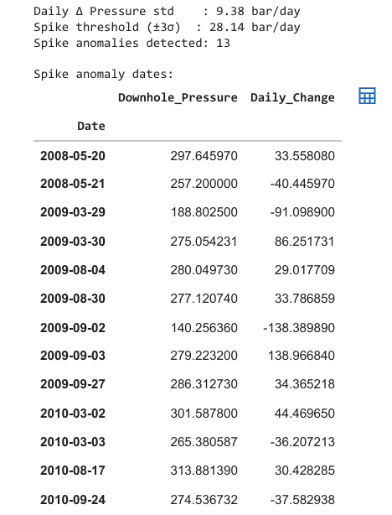
Explanation: The output displays the statistical characteristics of the daily pressure changes and the threshold used for spike detection. The standard deviation of daily pressure changes was found to be 9.38 bar/day, resulting in a spike detection threshold of ±28.14 bar/day. Using this criterion, 13 spike anomalies were identified within the study period. These anomalies correspond to days where the pressure changed much more rapidly than expected under normal operating conditions. The output table lists the anomaly dates, the corresponding downhole pressure values, and the magnitude of the daily pressure change. The largest pressure drop occurred on 2 September, 2009, indicating a significant abnormal event that warrants further investigation.
5.3.8. CREATING THE COMBINED ANOMALY MASTER TEST
all_dates = stat_anom.index.union(spike_anom.index)
master = pd.DataFrame(index=all_dates)
master.index.name = 'Date'
master['Pressure'] = p[all_dates]
master['Statistical'] = master.index.isin(stat_anom.index)
master['Spike'] = master.index.isin(spike_anom.index)
master.sort_index(inplace=True)
print(f'Total unique anomaly dates: {len(master)}')
print(f' Statistical only : {(master["Statistical"] & ~master["Spike"]).sum()}')
print(f' Spike only : {(~master["Statistical"] & master["Spike"]).sum()}')
print(f' Both methods : {(master["Statistical"] & master["Spike"]).sum()}')
print('\nMaster Anomaly List:')
display(master)
Explanation: This step combines the anomalies detected by the Statistical Anomaly Detection method and the Pressure Spike Detection method into a single master anomaly list. The anomaly dates identified by both techniques are merged using the union operation to ensure that every unique anomaly event is included. A new DataFrame called master is then created to store the anomaly information. For each anomaly date, the corresponding pressure value is recorded along with indicators showing whether the anomaly was detected by the statistical method, the spike detection method, or both. The master list provides a consolidated view of all anomalies identified up to this stage of the analysis. It also helps determine the level of agreement between the two detection methods and serves as the basis for subsequent root-cause investigation and machine learning-based anomaly detection.
OUTPUT:
The output summarizes the combined anomaly results obtained from the statistical and spike detection methods. A total of 24 unique anomaly dates were identified after merging the results.
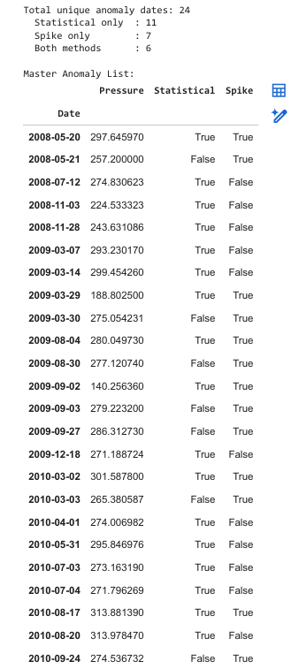
Among these anomalies:
- 11 anomalies were detected only by the statistical method.
- 7 anomalies were detected only by the spike detection method.
- 6 anomalies were detected by both methods.
The anomalies detected by both techniques represent stronger candidates for abnormal pressure behaviour because multiple independent methods identified the same event. The resulting master anomaly table displays each anomaly date, pressure value, and the detection methods responsible for identifying the anomaly.
5.3.9. ROOT-CAUSE INVESTIGATION OF DETECTED ANOMALIES
# Prepare aligned full dataset (2008-2010)
full = (
df_well
.set_index('DATEPRD')
.sort_index()
.loc['2008-01-01':'2010-12-31']
)
WINDOW = 7 # days either side of the anomaly
def get_window(col, date, days=WINDOW):
"""Return a Series slice ±days around the anomaly date."""
idx = pd.date_range(date - pd.Timedelta(days=days),
date + pd.Timedelta(days=days), freq='D')
return full[col].reindex(idx).dropna() if col in full.columns else pd.Series(dtype=float)
def get_cause(date):
causes = []
#CHECK 1: Shutdown
hrs = get_window('ON_STREAM_HRS', date)
if not hrs.empty and (hrs == 0).any():
causes.append('Shutdown')
#CHECK 2: Choke Change
chk = get_window('AVG_CHOKE_SIZE_P', date)
if len(chk) >= 2 and chk.mean() > 0 and (chk.std() / chk.mean()) > 0.15:
causes.append('Choke Change')
#CHECK 3: Water Breakthrough
oil = get_window('BORE_OIL_VOL', date)
wat = get_window('BORE_WAT_VOL', date)
if len(oil) >= 2 and len(wat) >= 2:
common_idx = oil.index.intersection(wat.index)
if len(common_idx) >= 2:
total = oil[common_idx] + wat[common_idx]
wcut = (wat[common_idx] / total.replace(0, np.nan)).dropna()
press_w = p.reindex(common_idx, method='nearest',
tolerance=pd.Timedelta('2D')).dropna()
if len(wcut) >= 2 and wcut.iloc[-1] > wcut.iloc[0]:
if len(press_w) >= 2 and press_w.iloc[-1] < press_w.iloc[0]:
causes.append('Water Breakthrough')
#CHECK 4: Gas Coning
gas = get_window('BORE_GAS_VOL', date)
oil2 = get_window('BORE_OIL_VOL', date)
if len(gas) >= 2 and len(oil2) >= 2:
common_idx2 = gas.index.intersection(oil2.index)
if len(common_idx2) >= 2:
gor = (gas[common_idx2] / oil2[common_idx2].replace(0, np.nan)).dropna()
if len(gor) >= 2 and gor.iloc[-1] > gor.iloc[0] * 1.2:
causes.append('Gas Coning')
return ', '.join(causes) if causes else 'Unexplained'
master['Cause'] = [get_cause(d) for d in master.index]
print('Root-cause investigation complete')
display(master[['Pressure','Statistical','Spike','Cause']])

Explanation: After identifying anomalous pressure events, a root-cause investigation is performed to determine the possible operational or reservoir-related reasons behind each anomaly. For every anomaly date, a ±7-day analysis window is examined using production and operational parameters from Well F-12.
Four potential causes are investigated:
- Shutdown Detection: Checks whether the well experienced zero production hours (ON_STREAM_HRS = 0) within the analysis window.
- Choke Change Detection: Evaluates variations in choke size using the coefficient of variation. Significant fluctuations may indicate operational adjustments affecting pressure behaviour.
- Water Breakthrough Detection: Identifies situations where water cut increases while downhole pressure decreases, suggesting the encroachment of water into the producing zone.
- Gas Coning Detection: Examines changes in the gas-oil ratio (GOR). A significant increase in GOR may indicate gas movement toward the wellbore.
If one or more conditions are satisfied, the corresponding cause is assigned to the anomaly. When none of the predefined conditions are detected, the anomaly is classified as Unexplained.
This investigation helps transform anomaly detection from simple event identification into a more meaningful diagnostic process by linking anomalies to potential physical causes.

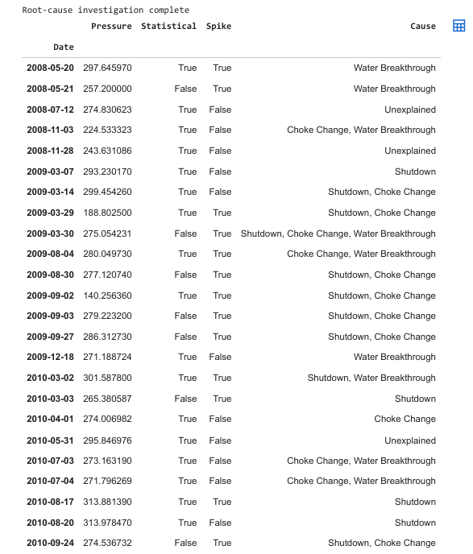
OUTPUT:
The output confirms that the root-cause investigation was successfully completed for all detected anomalies. Each anomaly is assigned one or more possible causes based on the evaluation criteria. The resulting table displays: The anomaly date, the recorded pressure value, whether the anomaly was detected by the statistical method, whether the anomaly was detected by the spike detection method, and the most likely operational or reservoir-related cause.
The analysis revealed that several anomalies were associated with water breakthrough, well shutdowns, and choke changes, while some anomalies could not be linked to any identifiable event and were therefore classified as Unexplained. This information provides valuable insight into the factors influencing abnormal pressure behaviour in Well F-12.
5.3.10. ISOLATION FOREST–BASED ANOMALY DETECTION
IF_FEATURES = ['AVG_WHP_P', 'AVG_DP_TUBING', 'AVG_ANNULUS_PRESS',
'AVG_CHOKE_SIZE_P', 'AVG_WHT_P']
avail = [c for c in IF_FEATURES if c in full.columns]
print(f'IF features available: {avail}')
ml_df = full[avail].dropna().copy()
scaler = StandardScaler()
X = scaler.fit_transform(ml_df)
iso = IsolationForest(n_estimators=200,
contamination=0.05,
random_state=42,
n_jobs=-1)
ml_df['IF_Label'] = iso.fit_predict(X)
ml_df['IF_Score'] = iso.score_samples(X) # lower = more anomalous
if_anom = ml_df[ml_df['IF_Label'] == -1][['IF_Score']].copy()
if_anom.index.name = 'Date'
print(f'\nIsolation Forest anomalies: {len(if_anom)}')
print(f'Anomaly score range : [{if_anom["IF_Score"].min():.4f}, {if_anom["IF_Score"].max():.4f}]')
display(if_anom.head(10))
Explanation: This step applies the Isolation Forest algorithm; an unsupervised machine learning technique designed specifically for anomaly detection. Unlike statistical methods that rely on predefined thresholds, Isolation Forest identifies anomalies by isolating observations that differ significantly from normal data patterns.
Five operational and pressure-related variables are selected as input features:
- Average Wellhead Pressure (AVG_WHP_P)
- Average Tubing Pressure Difference (AVG_DP_TUBING)
- Average Annulus Pressure (AVG_ANNULUS_PRESS)
- Average Choke Size (AVG_CHOKE_SIZE_P)
- Average Wellhead Temperature (AVG_WHT_P)
Before model training, all features are standardized using StandardScaler to ensure that differences in measurement units do not influence the anomaly detection process.
The Isolation Forest model is then trained using:
- 200 decision trees (estimators)
- Contamination = 0.05 (approximately 5% expected anomalies)
- Random state = 42 for reproducibility
The algorithm assigns each observation an anomaly label and an anomaly score. Observations labelled ‘-1’ are considered anomalous, while observations labelled ‘1’ are considered normal. Lower anomaly scores indicate a greater degree of abnormality.
The detected anomalies are stored for subsequent comparison with the statistical and spike detection results.
OUTPUT:
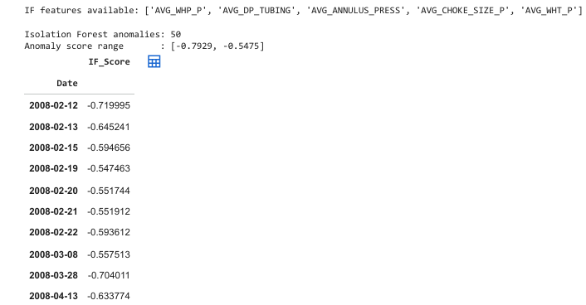
The output first confirms the availability of the selected input features used for machine learning analysis. After training the Isolation Forest model, a total of 50 anomaly events were identified. The anomaly score range provides an indication of anomaly severity. More negative scores represent observations that are easier for the model to isolate and therefore more likely to be true anomalies. The displayed table presents the first ten detected anomalies together with their corresponding anomaly scores. These results demonstrate the ability of Isolation Forest to detect multivariate anomalies that may not be visible through pressure data alone.

5.3.11 CONFIDENCE CLASSIFICATION OF DETECTED ANOMALIES
master['IF'] = master.index.isin(if_anom.index)
master['Methods'] = (master['Statistical'].astype(int) +
master['Spike'].astype(int) +
master['IF'].astype(int))
def classify(row):
if row['Methods'] >= 3: return 'High'
if row['Methods'] == 2: return 'Medium'
return 'Low'
def method_str(row):
m = []
if row['Statistical']: m.append('Statistical')
if row['Spike']: m.append('Spike')
if row['IF']: m.append('IF')
return ' + '.join(m) if m else 'None'
master['Confidence'] = master.apply(classify, axis=1)
master['Detection_Method'] = master.apply(method_str, axis=1)
conf_counts = master['Confidence'].value_counts()
print('Confidence breakdown:')
for level in ['High','Medium','Low']:
print(f' {level:<8}: {conf_counts.get(level, 0)}')
display(master[['Pressure','Detection_Method','Confidence','Cause']])

Explanation: This step integrates the results from all three anomaly detection techniques: Statistical Anomaly Detection, Pressure Spike Detection, and Isolation Forest, to determine the confidence level of each detected anomaly. For every anomaly date, the number of detection methods that identified the anomaly is counted. This count is stored in the Methods column and is used to assign a confidence level according to the following criteria:
- High Confidence: Detected by all three methods.
- Medium Confidence: Detected by any two methods.
- Low Confidence: Detected by only one method.
A separate function is also used to record the specific detection methods responsible for identifying each anomaly. This provides transparency regarding how each anomaly was detected and allows comparison between the different approaches. The confidence classification helps prioritize anomaly investigation, as anomalies identified by multiple independent methods are generally more reliable indicators of abnormal well behaviour than those detected by only a single technique.

Output:
The output summarizes the distribution of anomalies according to their confidence levels. The results indicate the degree of agreement between the three detection methods and provide an overall measure of anomaly reliability. The analysis identified:
- 1 High-Confidence anomaly, detected by all three methods.
- 8 Medium-Confidence anomalies, detected by two methods.
- 15 Low-Confidence anomalies, detected by only one method.
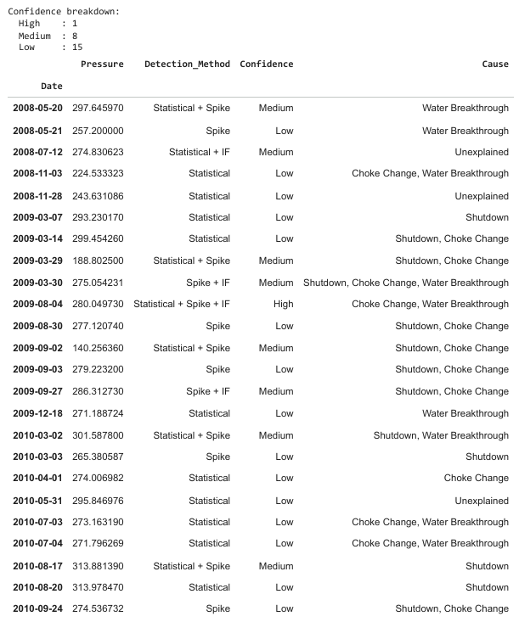
The final anomaly table displays the pressure value, detection methods, confidence level, and inferred root cause for each anomaly. This table represents the final outcome of the anomaly detection framework and provides a comprehensive overview of abnormal pressure events observed in Well F-12.

5.3.12 GENERATING AND EXPORTING THE FINAL ANOMALY TABLE
final_table = master[['Pressure','Detection_Method','Cause','Confidence']].copy()
final_table.index = final_table.index.strftime('%Y-%m-%d')
final_table.index.name = 'Date'
final_table.columns = ['Pressure (bar)', 'Detection Method', 'Cause', 'Confidence']
print('='*80)
print('FINAL ANOMALY TABLE — Well F-12 (2008–2010)')
print('='*80)
display(final_table)
# Save as CSV
csv_bytes = final_table.to_csv().encode()
with open('F12_anomaly_table.csv', 'wb') as f:
f.write(csv_bytes)
print('\n ✅ Saved: F12_anomaly_table.csv')
files.download('F12_anomaly_table.csv')

Explanation: This final step prepares the anomaly detection results for reporting and future analysis. The relevant information from the master anomaly dataset is extracted, including:
- Pressure value at the anomaly date
- Detection method(s) responsible for identifying the anomaly
- Inferred root cause
- Confidence level
The anomaly dates are formatted into a standard YYYY-MM-DD format to improve readability and consistency. Column names are also renamed to descriptive labels suitable for reporting and publication. The resulting dataset is stored in a new DataFrame called final_table, which serves as the final summary of all detected pressure anomalies in Well F-12 during the 2008–2010 study period. To facilitate further analysis and documentation, the table is exported as a CSV file named F12_anomaly_table.csv. The file can then be downloaded and used in reports, presentations, or future studies.

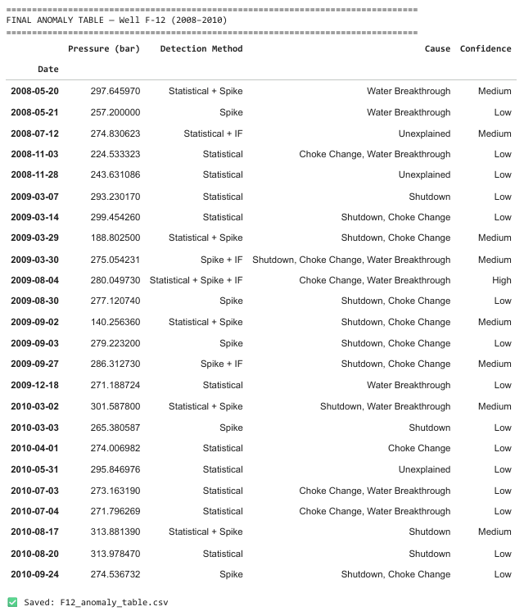
OUTPUT:
The output displays the complete anomaly summary table containing all detected anomaly events. Each record includes the pressure value, detection methods, probable cause, and confidence classification. The table represents the final result of the pressure anomaly detection workflow and provides a consolidated view of abnormal pressure events identified within the study period. The exported CSV file ensures that the results are preserved in a structured format for future reference.

5.3.13 DEFINING THE VISUALIZATION COLOUR PALETTE
#Colour palette
C = {
'pressure' : '#2c7bb6',
'bounds' : '#d7191c',
'roll_mean' : '#fdae61',
'anomaly' : '#d7191c',
'spike' : '#e66101',
'if_anom' : '#7b2d8b',
'shutdown' : '#d7191c',
'choke' : '#fdae61',
'water' : '#2c7bb6',
'gas' : '#1a9641',
'unexplain' : '#888888',
}
cause_palette = {
'Shutdown' : C['shutdown'],
'Choke Change' : C['choke'],
'Water Breakthrough' : C['water'],
'Gas Coning' : C['gas'],
'Unexplained' : C['unexplain'],
}
print('Colour palette ready✅')
Explanation: This section defines a standardized colour palette that will be used throughout the visualization stage of the pressure anomaly detection workflow. Assigning consistent colours to different pressure trends, anomaly types, and root causes improves the readability and interpretation of graphs. A dictionary named C is created to store colour codes for pressure curves, anomaly markers, rolling statistics, and various root-cause categories. Another dictionary, cause_palette, maps each identified anomaly cause to a specific colour. Using a predefined colour scheme ensures visual consistency across all figures and helps distinguish different anomaly categories when displaying plots and charts.
OUTPUT:

The output confirms that the colour palette has been successfully created and is ready to be used in subsequent visualizations. No calculations or anomaly detections are performed in this step; it simply prepares the graphical settings required for plotting the results.
5.3.14 VISUALIZING PRESSURE TREND AND STATISTICAL ANOMALIES
fig1, ax1 = plt.subplots(figsize=(14, 5))
ax1.fill_between(p.index, lower_bound, upper_bound,
alpha=0.12, color=C['bounds'], label='±3σ rolling bounds')
ax1.plot(p.index, roll_mean, color=C['roll_mean'],
linewidth=1.3, linestyle='--', label='30-day rolling mean')
ax1.plot(p.index, p, color=C['pressure'],
linewidth=1, label='Downhole Pressure')
ax1.scatter(stat_anom.index, stat_anom['Downhole_Pressure'],
color=C['anomaly'], zorder=5, s=70,
label=f'Statistical anomaly (n={len(stat_anom)})')
ax1.set_title('Figure 1 — Well F-12: Downhole Pressure vs Time (2008–2010)',
fontsize=13, fontweight='bold')
ax1.set_xlabel('Date'); ax1.set_ylabel('Pressure (bar)')
ax1.legend(fontsize=8, loc='lower right')
ax1.grid(True, alpha=0.3)
plt.tight_layout()
plt.savefig('F12_Fig1_Pressure_vs_Time.png', dpi=150, bbox_inches='tight')
plt.show()
print('✅ Figure 1 saved')
Explanation: This step generates a time-series visualization of the downhole pressure data together with the rolling statistical limits used for anomaly detection. The plot combines the actual pressure measurements, the 30-day rolling mean, and the dynamic ±3σ rolling boundaries calculated earlier in the analysis.
The downhole pressure trend is plotted as a continuous line, while the rolling mean represents the expected local pressure behavior. The shaded region between the upper and lower rolling bounds defines the normal operating range.
Pressure observations identified as statistical anomalies are highlighted using distinct markers to make abnormal events easily visible.
The completed figure is saved as F12_Fig1_Pressure_vs_Time.png for inclusion in reports and presentations.
OUTPUT:
Figure 9 presents the variation of downhole pressure in Well F-12 between 2008 and 2010. The blue curve represents the measured downhole pressure, while the orange dashed line shows the 30-day rolling mean. The shaded red region indicates the adaptive ±3σ operating envelope.
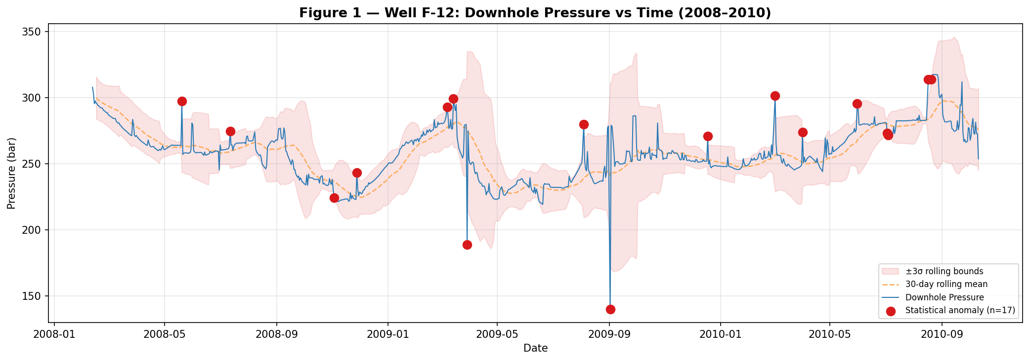
Figure 9: Downhole Pressure Trend and Statistical Anomaly Detection for Well F-12 (2008–2010)
The highlighted anomaly points represent pressure observations that fall outside the rolling statistical limits. A total of 17 statistical anomalies were detected. The figure demonstrates that the rolling-window approach successfully adapts to the gradual decline in reservoir pressure while still identifying significant abnormal pressure events.
Unlike fixed global thresholds, the rolling statistical method accounts for changing reservoir conditions and therefore provides a more reliable mechanism for anomaly detection in declining pressure systems.
5.3.15 VISUALIZING PRESSURE SPIKE DETECTION
fig2, (ax2a, ax2b) = plt.subplots(2, 1, figsize=(14, 7), sharex=True)
# Top: pressure with spike markers
ax2a.plot(p.index, p, color=C['pressure'], linewidth=1)
ax2a.scatter(spike_anom.index, spike_anom['Downhole_Pressure'],
color=C['spike'], zorder=5, s=80,
label=f'Spike anomaly (n={len(spike_anom)})')
ax2a.set_ylabel('Pressure (bar)')
ax2a.set_title('Figure 2 — Pressure Spike Detection', fontsize=13, fontweight='bold')
ax2a.legend(fontsize=8); ax2a.grid(True, alpha=0.3)
# Bottom: daily change bar chart
bar_colors = [C['spike'] if m else '#aec7e8' for m in spike_mask]
ax2b.bar(daily_change.index, daily_change.values, color=bar_colors, width=1)
ax2b.axhline( spike_threshold, color=C['bounds'], linestyle='--', linewidth=1.2,
label=f'+3σ threshold ({spike_threshold:.1f} bar/day)')
ax2b.axhline(-spike_threshold, color=C['bounds'], linestyle='--', linewidth=1.2,
label=f'-3σ threshold ({-spike_threshold:.1f} bar/day)')
ax2b.set_ylabel('Daily Δ Pressure (bar/day)')
ax2b.set_xlabel('Date')
ax2b.legend(fontsize=8); ax2b.grid(True, alpha=0.3)
plt.tight_layout()
plt.savefig('F12_Fig2_Spike_Detection.png', dpi=150, bbox_inches='tight')
plt.show()
print('✅ Figure 2 saved')

Explanation: This step generates a two-panel figure to visualize the results of the pressure spike detection analysis. The upper panel displays the downhole pressure trend together with the detected spike anomalies, while the lower panel illustrates the day-to-day pressure changes used for anomaly identification.
In the upper panel, all detected spike anomalies are highlighted on the pressure time-series, allowing abnormal pressure events to be easily distinguished from normal pressure behaviour. In the lower panel, daily pressure changes are represented as a bar chart, where spike anomalies are shown in a different colour from normal observations.
The positive and negative spike detection thresholds (±3σ) are also plotted as horizontal reference lines. Any daily pressure change exceeding these limits is classified as a spike anomaly. This visualization helps verify that the detected anomalies correspond to unusually large pressure fluctuations.
The completed figure is saved as F12_Fig2_Spike_Detection.png for inclusion in the project report.

OUTPUT:
Figure 10 illustrates the pressure spike detection results for Well F-12 during the 2008–2010 study period. The upper plot shows the downhole pressure profile with detected spike anomalies highlighted. The lower plot presents the daily pressure changes together with the ±3σ spike thresholds.
The figure demonstrates that the majority of pressure changes remain within the normal operating range, while a small number of observations exceed the threshold and are therefore classified as spike anomalies. A total of 13 spike anomalies were detected. These events represent sudden pressure increase or decrease that may be associated with operational interventions, equipment issues, or abrupt reservoir behaviour changes.
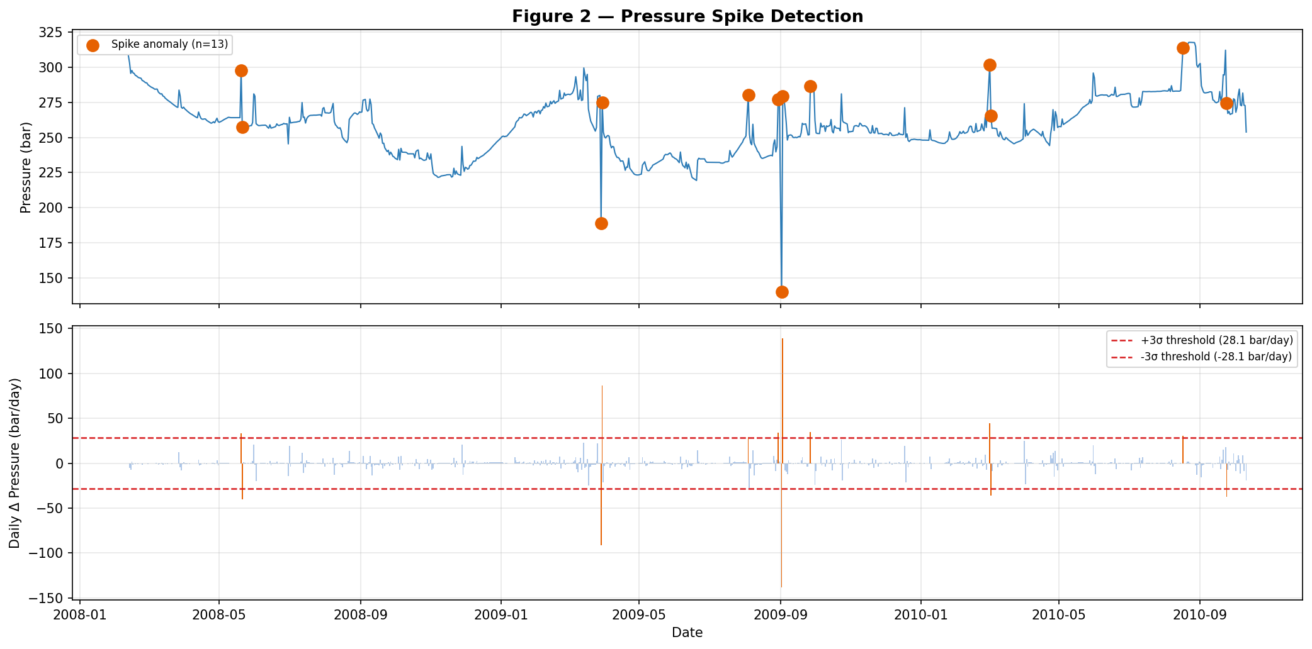
Figure 10: Pressure Spike Detection in Well F-12 Showing Downhole Pressure Trends, Daily Pressure Changes, and ±3σ Spike Thresholds (2008–2010)
5.3.16 VISUALIZING ISOLATION FOREST ANOMALIES
fig3, ax3 = plt.subplots(figsize=(14, 5))
ax3.plot(p.index, p, color=C['pressure'], linewidth=1, label='Downhole Pressure')
if not if_anom.empty:
if_dates = if_anom.index.intersection(p.index)
# also try nearest-date match for non-exact
if_in_press = p.reindex(if_anom.index, method='nearest',
tolerance=pd.Timedelta('2D')).dropna()
ax3.scatter(if_in_press.index, if_in_press.values,
color=C['if_anom'], zorder=5, s=70, marker='D',
label=f'Isolation Forest anomaly (n={len(if_in_press)})')
ax3.set_title('Figure 3 — Isolation Forest Anomaly Detection (Multivariate)',
fontsize=13, fontweight='bold')
ax3.set_xlabel('Date'); ax3.set_ylabel('Pressure (bar)')
ax3.legend(fontsize=8); ax3.grid(True, alpha=0.3)
plt.tight_layout()
plt.savefig('F12_Fig3_IsolationForest.png', dpi=150, bbox_inches='tight')
plt.show()
print('✅ Figure 3 saved')

Explanation: This step visualizes the anomalies detected by the Isolation Forest model. The downhole pressure data are plotted as a time-series curve, and the observations identified as anomalies by the machine learning algorithm are highlighted using diamond-shaped markers. Since Isolation Forest is a multivariate anomaly detection method, anomalies are detected based on the combined behaviour of several operational parameters rather than pressure alone. Therefore, some anomalies identified by the model may not appear as obvious outliers in the pressure trend but can still represent unusual well conditions when multiple variables are considered simultaneously. To ensure proper alignment with the pressure series, anomaly dates are matched with the nearest available pressure observations before plotting. This allows the detected machine learning anomalies to be visualized directly on the pressure timeline.

The completed figure is saved as F12_Fig3_IsolationForest.png for inclusion in the project report.

OUTPUT:
Figure 11 presents the results of the Isolation Forest anomaly detection model applied to Well F-12. The blue line represents the downhole pressure trend, while the purple diamond markers indicate observations classified as anomalous by the Isolation Forest algorithm.
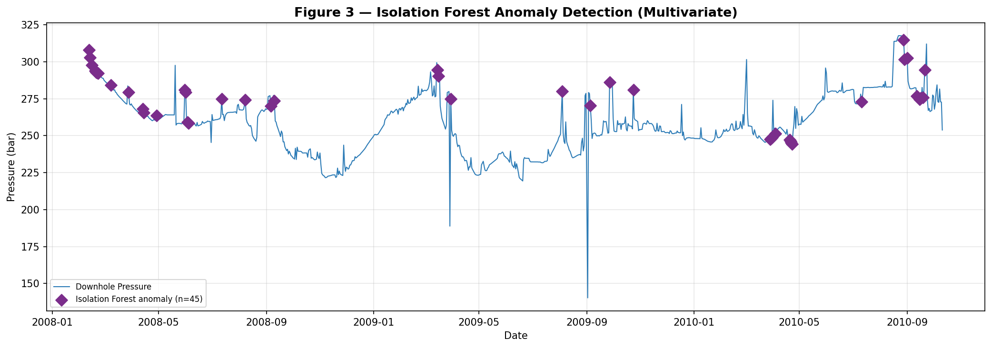
Unlike the statistical and spike detection methods, Isolation Forest evaluates multiple operational variables simultaneously. As a result, the detected anomalies represent complex operational conditions that may not be evident from pressure measurements alone. The figure demonstrates the ability of machine learning techniques to identify subtle multivariate anomalies that could otherwise remain undetected. A total of 50 anomalies were identified by the Isolation Forest model during the study period.
Figure 11: Isolation Forest–Based Multivariate Anomaly Detection for Well F-12 Showing Detected Anomalous Pressure Events (2008–2010)
5.3.17 VISUALIZING ROOT-CAUSE ANALYSIS OF PRESSURE ANOMALIES
# Expand multi-cause rows
primary_causes = master['Cause'].apply(lambda x: x.split(', ')[0])
all_cause_rows = [c.strip() for row in master['Cause'] for c in row.split(', ')]
cause_series = pd.Series(all_cause_rows)
fig4 = plt.figure(figsize=(15, 6))
gs = gridspec.GridSpec(1, 2, width_ratios=[1.5, 1], figure=fig4)
# Left: timeline coloured by primary cause
ax4a = fig4.add_subplot(gs[0])
ax4a.plot(p.index, p, color=C['pressure'], linewidth=0.9, alpha=0.55, label='Pressure')
for cause, colour in cause_palette.items():
sub = master[primary_causes == cause]
if not sub.empty:
ax4a.scatter(sub.index, sub['Pressure'], color=colour, s=85,
zorder=5, label=cause)
ax4a.set_title('Anomaly Causes — Timeline', fontsize=11, fontweight='bold')
ax4a.set_xlabel('Date'); ax4a.set_ylabel('Pressure (bar)')
ax4a.legend(fontsize=8); ax4a.grid(True, alpha=0.3)
# Right: horizontal bar chart
ax4b = fig4.add_subplot(gs[1])
cause_counts = cause_series.value_counts()
bar_colors = [cause_palette.get(c, '#999') for c in cause_counts.index]
bars = ax4b.barh(cause_counts.index, cause_counts.values, color=bar_colors, edgecolor='white')
for bar, val in zip(bars, cause_counts.values):
ax4b.text(bar.get_width() + 0.08, bar.get_y() + bar.get_height()/2,
str(val), va='center', fontsize=10, fontweight='bold')
ax4b.set_xlabel('Count'); ax4b.set_xlim(0, cause_counts.max() + 2)
ax4b.set_title('Cause Breakdown', fontsize=11, fontweight='bold')
ax4b.grid(True, alpha=0.3, axis='x')
fig4.suptitle('Figure 4 — Root-Cause Analysis of Pressure Anomalies (F-12 · 2008–2010)',
fontsize=13, fontweight='bold')
plt.tight_layout()
plt.savefig('F12_Fig4_Causes.png', dpi=150, bbox_inches='tight')
plt.show()
print('✅Figure 4 saved')
Explanation: This step generates a comprehensive visualization of the root-cause analysis results obtained from the detected pressure anomalies. The figure consists of two complementary plots that illustrate both the temporal occurrence of anomaly causes and their overall frequency distribution. To simplify visualization, anomalies associated with multiple causes are assigned a primary cause based on the first identified cause in the anomaly record. The left panel presents a timeline of pressure anomalies, where each anomaly is colour-coded according to its inferred cause. This enables the relationship between anomaly occurrence and pressure behaviour to be examined over time. The right panel displays a horizontal bar chart showing the number of anomalies associated with each cause category. The bar chart provides a summary of the dominant factors contributing to abnormal pressure behaviour in Well F-12.
The completed figure is saved as F12_Fig4_Causes.png for inclusion in the final report.
OUTPUT:
Figure 12 presents the root-cause analysis of the detected pressure anomalies in Well F-12 during the 2008–2010 study period. The left-hand plot illustrates the anomaly timeline, where each anomaly is coloured according to its inferred cause, including Shutdown, Choke Change, Water Breakthrough, Gas Coning, and Unexplained events.
The right-hand plot summarizes the frequency of each cause category. This visualization allows the most significant contributors to pressure anomalies to be identified quickly. The results indicate that operational events such as shutdowns and choke adjustments, together with reservoir-related phenomena such as water breakthrough, were responsible for a substantial proportion of the detected anomalies. Some anomalies remained unexplained, suggesting the presence of additional influencing factors not captured by the available data. Together, these plots provide a clearer understanding of the underlying mechanisms responsible for abnormal pressure behaviour and support more informed operational decision-making.
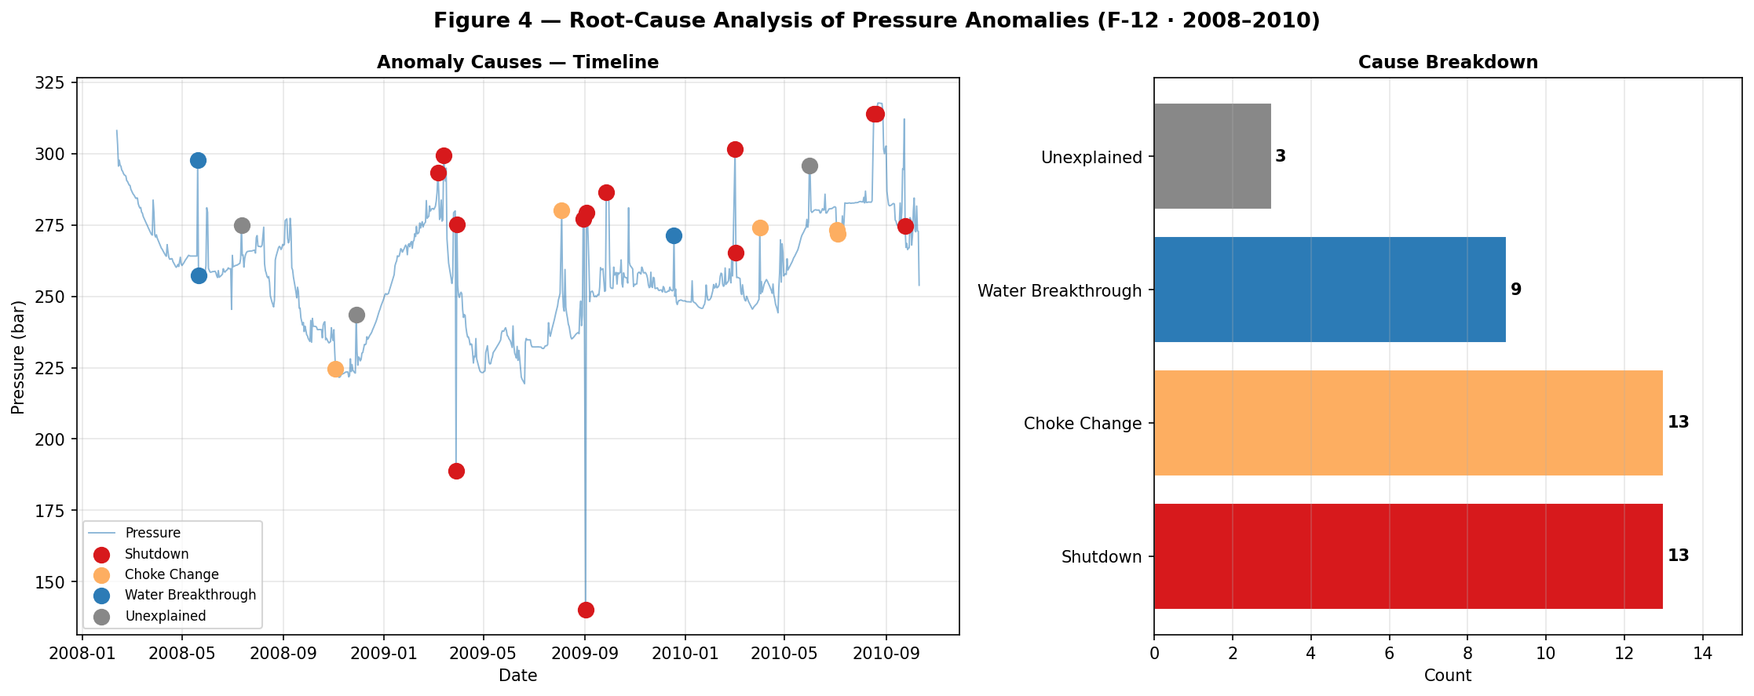
Figure 12: Root-Cause Analysis of Pressure Anomalies in Well F-12 Showing Anomaly Timeline and Cause Distribution (2008–2010)
5.3.18 GENERATING THE FINAL SUMMARY REPORT
def count_cause(keyword):
return int(primary_causes.str.contains(keyword, case=False, na=False).sum())

total_readings = len(df_press)
total_anom = len(master)

shutdown_n = count_cause('Shutdown')
choke_n = count_cause('Choke')
water_n = count_cause('Water')
gas_n = count_cause('Gas')
unexplained_n = count_cause('Unexplained')

high_n = int((master['Confidence'] == 'High').sum())
med_n = int((master['Confidence'] == 'Medium').sum())
low_n = int((master['Confidence'] == 'Low').sum())

report = f"""
F-12 PRESSURE ANOMALY DETECTION – FINAL RESULTS

Well : NO 15/9-F-12 H
Period : 2008 – 2010

Total valid pressure readings : {total_readings}
Total anomalies detected : {total_anom}

CONFIDENCE LEVELS
-----------------
High Confidence : {high_n}
Medium Confidence : {med_n}
Low Confidence : {low_n}

ROOT CAUSES
-----------
Shutdown-related : {shutdown_n}
Choke Change : {choke_n}
Water Breakthrough : {water_n}
Gas Coning : {gas_n}
Unexplained : {unexplained_n}

"""

print(report)

with open('F12_anomaly_report.txt', 'w') as f:
f.write(report)

print("\n✅ Report saved: F12_anomaly_report.txt")
Explanation: This step generates a concise summary report containing the key findings of the pressure anomaly detection study. Several statistics are calculated from the final anomaly dataset, including the total number of valid pressure readings, the total number of detected anomalies, confidence-level distribution, and root-cause frequencies. A helper function named count_cause() is used to count the occurrence of each root-cause category. The report then compiles all important results into a formatted text summary, providing a quick overview of the anomaly detection analysis without requiring the user to inspect the complete anomaly table. The generated report includes:
- Well information and study period.
- Total valid pressure observations.
- Total anomalies detected.
- Confidence-level breakdown.
- Root-cause distribution.
- Generated output files.
The completed report is displayed in the notebook and saved as a text file named F12_anomaly_report.txt for documentation and future reference.

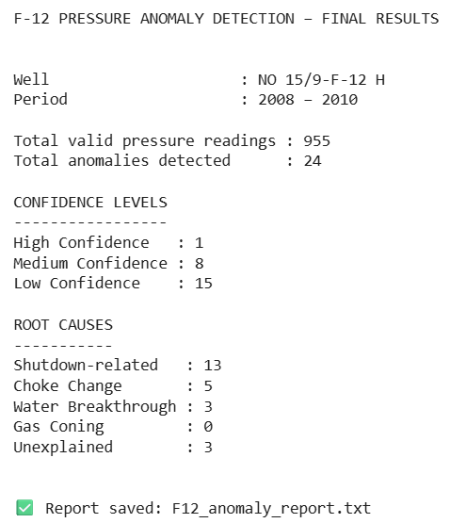
OUTPUT:

The output displays a summary of the final pressure anomaly detection results for Well F-12. It presents the overall statistics of the study, including the number of anomalies detected, their confidence classifications, and the distribution of identified root causes.
This summary provides a concise overview of the entire workflow and serves as a convenient reference for interpreting the final results. The report also lists all generated output files, including anomaly tables and visualization figures.

CHAPTER 6: RESULTS
6.1 PRODUCTION FORECASTING MODEL RESULTS
The overall results clearly show that the model worked successfully for production forecasting. The high R² values for both the training and testing datasets indicate that the model was able to learn the relationship between past production behavior and future production rates in a reliable manner. The low prediction errors in the test dataset further confirm that the model performs well on unseen data, which is a key requirement for any forecasting application.


The model’s success is strongly linked to the choice of input features used during training. The primary feature used was the historical production rate, which carries strong time-dependent information. Oil production data generally shows continuity, where the production on a given day is closely related to production in the preceding days. By learning from these past production values and their short-term and medium-term trends, the model was able to capture decline behavior and small fluctuations effectively.
Since production rate reflects the combined effect of reservoir properties, operational conditions, and natural depletion, it acts as a powerful indicator of future performance even without explicitly including all physical parameters. The model learned patterns such as gradual decline, stable periods, and minor variability directly from the production rate data, allowing it to generate realistic and smooth forecasts.
Overall, the results demonstrate that using historical production rate as the key feature is sufficient for accurate short-term forecasting in this study. The model successfully captures temporal patterns, shows good generalization, and provides dependable predictions that can be used to understand future production trends. This confirms that the machine learning approach adopted in this project is effective and practically applicable for production forecasting based on available production data.
6.2. PRESSURE ANOMALY DETECTION MODEL RESULTS
The pressure anomaly detection framework was applied to the downhole pressure data of Well F12 for the period 2008 to 2010. A total of 955 valid pressure observations were analyzed using a hybrid anomaly detection approach consisting of Statistical Anomaly Detection, Pressure Spike Detection and Isolation Forest.
The statistical rolling window method identified 17 anomalies by detecting pressure values that exceeded the adaptive ±3σ control limits. The pressure spike detection method identified 13 anomalies based on abnormal day to day pressure changes exceeding the ±3σ spike threshold of 28.14 bar/day. The Isolation Forest model, which incorporated multiple operational parameters, detected 50 multivariate anomalies.
After combining the results from all detection methods, 24 unique anomaly events were identified. Among these anomalies, 11 were detected only by the statistical method, 7 only by the spike detection method and 6 by both methods. The Isolation Forest model provided additional multivariate insights that complemented the pressure-based detection techniques.
Root cause investigation was conducted for each anomaly using operational and production parameters. The analysis revealed that several anomalies were associated with well shutdowns, choke changes, water breakthrough and gas coning, while some anomalies could not be linked to any specific operational event and were therefore classified as unexplained.

A confidence classification system was implemented based on the agreement among the three detection methods. The results showed 1 High Confidence anomaly, 8 Medium Confidence anomalies and 15 Low Confidence anomalies. High Confidence anomalies were detected by all three methods simultaneously and therefore represent the most reliable indicators of abnormal well behaviour.

The results demonstrate that the integration of statistical methods and machine learning techniques provides a robust approach for pressure anomaly detection. While the statistical and spike detection methods effectively identified sudden pressure deviations, the Isolation Forest model was able to detect more complex multivariate anomalies. Together, these methods improved anomaly detection reliability and provided valuable insights into the operational and reservoir conditions affecting Well F12.

CHAPTER 7: CONCLUSION
This project demonstrated the application of machine learning techniques for production forecasting and pressure anomaly detection using data from Well F-12 of the Volve oil field. The study aimed to improve reservoir monitoring and operational decision making by developing data driven models capable of predicting future oil production and identifying abnormal pressure behaviour.
For production forecasting, a Random Forest Regression model was developed using engineered features derived from historical production data. The model successfully captured the complex and non-linear relationships present in the dataset and generated reliable forecasts of future oil production. The results showed that machine learning can effectively model production trends and provide valuable support for production planning and reservoir management.
For pressure anomaly detection, a hybrid framework combining Statistical Anomaly Detection, Pressure Spike Detection, and Isolation Forest was implemented. The statistical method identified anomalies based on adaptive rolling control limits, while spike detection captured sudden pressure changes. The Isolation Forest algorithm provided additional multivariate analysis by considering several operational parameters simultaneously. The integration of these methods enabled the identification of 24 unique anomaly events and provided greater detection reliability than any individual technique alone.
Root cause investigation further linked several anomalies to operational and reservoir related factors such as well shutdowns, choke changes, water breakthrough, and gas coning. The confidence classification system helped prioritize anomalies based on the level of agreement among the detection methods.
Overall, the study demonstrates that machine learning techniques can be effectively applied to petroleum engineering problems. The developed framework provides a practical approach for analysing field data, improving operational awareness, and supporting data driven decision making in oil and gas production systems.

GLOSSARY
1. Calibrate: To adjust a method or system so that its outputs better match expected or observed results.
2. Calendar Based Effects: Patterns in data that repeat according to dates, such as daily, weekly, or yearly cycles.
3. Cluster: A group of items or data points that are similar to each other.
4. Constraints: Rules or limits that restrict how a system or model can operate.
5. CPU Cores: Independent processing units within a computer that allow tasks to run in parallel.
6. CSV: A file format used to store data in rows and columns, with values separated by commas.
7. Data Leakage: When information from outside the intended training data influences a model, causing misleading results.
8. DataFrame: A structured table used to store and analyze data in rows and columns.
9. Date Index: A sequence of dates used to organize data over time.
10. Decline Trends: A consistent downward pattern observed in data over a period of time.
11. Depletion Dominated: A condition where values mainly decrease because available resources or capacity are being used up.
12. Exponential Moving Average: A method that smooths data by giving more importance to recent values.
13. Feature Engineering: The process of creating or modifying input variables to improve model performance.
14. Field Deployment: Putting a developed model or system into real world use.
15. Formatting: Adjusting the appearance and layout of data or visuals to make them easier to understand.
16. Generalization: The ability of a model or method to work well on new, unseen data.
17. Histogram: A chart that shows how often values occur within specific ranges.
18. Historical Production Data: Previously recorded production values collected over time.
19. Importance Score: A value that indicates how influential a particular input is in making predictions.
20. Input Features: The variables or data provided to a model to generate outputs.
21. Interventions: Actions taken to intentionally change or influence system behaviour.
22. Isolation Forest: An unsupervised machine learning algorithm used to detect anomalies by isolating observations that differ from normal patterns.
23. Lagged Features: Past values used to help predict future values.
24. Late Life Production: A stage where production rates are low and continue to decrease over time.
25. Leaf Nodes: End points in a decision structure where final outcomes are produced.
26. Legend: An explanation on a chart that identifies symbols, colours, or lines.
27. Long Term Trend: The overall direction of data observed over a long time period.
28. MAE (Mean Absolute Error): A measure of the average absolute difference between actual and predicted values.
29. Machine Learning: A branch of artificial intelligence that enables computers to learn patterns from data and make predictions.
30. Medium Term Trend: A pattern observed over a moderate time span between short term changes and long-term behaviour.
31. Moving Averages: Techniques used to smooth data by averaging values over a selected window.
32. Multiple Lagged Features: The use of several past values as inputs for prediction.
33. Node Splitting: The process of dividing data into smaller groups based on conditions.
34. Noise Fitting: When a model learns random variations instead of meaningful patterns.
35. Oil in Place: The total amount of hydrocarbons present in a reservoir before production begins.
36. Overfitting: A condition where a model performs well on training data but poorly on new unseen data.
37. Overlapping: When values or ranges intersect, making distinctions less clear.
38. Overprediction: When predicted values are higher than actual values.
39. Parse Dates: Converting date text into a format that can be processed and analyzed.
40. Pressure Anomaly Detection: The process of identifying abnormal pressure behaviour that may indicate operational issues, equipment failures, or reservoir problems.
41. Production Forecasting: The process of predicting future oil production using historical production data and analytical models.
42. Random Forest Regressor: An ensemble machine learning algorithm that combines multiple decision trees to predict continuous values such as oil production rates.
43. Regression: A machine learning technique used to predict continuous numerical values.
44. Reservoir Depletion: The gradual reduction of reservoir pressure and recoverable hydrocarbons due to continuous production.
45. RMSE (Root Mean Square Error): A performance metric that measures the average magnitude of prediction errors while giving greater weight to larger errors.
46. Rolling Mean: A moving average calculated over a specified time window to smooth short term fluctuations in data.
47. Root Cause Analysis: The process of identifying the underlying reason for an observed event or anomaly.
48. R² Score (Coefficient of Determination): A statistical measure indicating how well a model explains the variability of the target variable.
49. Spike Detection: A statistical technique used to identify sudden increase or decrease in pressure values.
50. StandardScaler: A data normalization technique that transforms variables to have a mean of zero and a standard deviation of one.
51. STB/D (Stock Tank Barrels per Day): A standard unit used in the petroleum industry to measure daily oil production rates.
52. Time Series Data: A sequence of observations recorded over time at regular intervals.
54. Water Breakthrough: The production of increasing amounts of water from a reservoir, often accompanied by declining pressure and oil production.
55. Gas Coning: The movement of gas toward the production zone of a well, resulting in increased gas production and abnormal pressure behaviour.
REFERENCES
- Zhenis, et al. (2025). Machine learning techniques for bottomhole pressure monitoring in production wells: A comprehensive review. Journal of Petroleum Science and Engineering.
- Bojer, C. S. (2022). Understanding machine learning-based forecasting methods: A decomposition framework and research opportunities. International Journal of Forecasting, 38(4), 1555–1561. https://doi.org/10.1016/j.ijforecast.2021.11.003
- Liaw, A., & Wiener, M. (2002). Classification and Regression by randomForest. R News, 2(3), 18–22.
- Equinor. (2018). Volve Field Data Village [Dataset]. Equinor ASA.
- Ng, C. S. W., Ghahfarokhi, A. J., & Amar, M. N. (2021). Well production forecast in Volve field: Application of rigorous machine learning techniques and metaheuristic algorithm. Journal of Petroleum Science and Engineering, 208, 109468. https://doi.org/10.1016/j.petrol.2021.109468
- Dornadula, V. N., et al. (2024). Smart predictions of petrophysical formation pore pressure using robust data-driven intelligent models. [Study using Volve Field data, 22,539 data points across five wells].
- Siddique, A. B., Munshi, T. A., Rakin, N. I., Hashan, M., Chnapa, S. S., & Jahan, L. N. (2025). Application of supervised machine learning and unsupervised data compression models for pore pressure prediction employing drilling, petrophysical, and well log data. Scientific Reports, 15(1). https://doi.org/10.1038/s41598-025-89199-3
- Aydin, G. (2014). Production modeling in the oil and natural gas industry: An application of trend analysis. Petroleum Science and Technology, 32(5), 555–564. https://doi.org/10.1080/10916466.2013.825271
- Hajizadeh, Y. (2019). Machine learning in oil and gas; a SWOT analysis approach. Journal of Petroleum Science and Engineering, 176, 661–663. https://doi.org/10.1016/j.petrol.2019.01.113
- Sircar, A., Yadav, K., Rayavarapu, K., Bist, N., & Oza, H. (2021). Application of machine learning and artificial intelligence in oil and gas industry. Petroleum Research, 6(4), 379–391. https://doi.org/10.1016/j.ptlrs.2021.05.009
- Sami, N. A., & Ibrahim, D. S. (2021). Forecasting multiphase flowing bottom-hole pressure of vertical oil wells using three machine learning techniques. Petroleum Research, 6(4), 417–422. https://doi.org/10.1016/j.ptlrs.2021.05.004
- Goliatt, L., Mohammad, R. S., Abba, S. I., & Yaseen, Z. M. (2023). Development of hybrid computational data-intelligence model for flowing bottom-hole pressure of oil wells. Fuel, 350, 128623. https://doi.org/10.1016/j.fuel.2023.128623
- Starikov, V., Shchipanov, A., Demyanov, V., & Muradov, K. (2024). Feature extraction and pattern recognition in time-lapse pressure transient responses. Geoenergy Science and Engineering, 242, 213160. https://doi.org/10.1016/j.geoen.2024.213160
- Rossi, D. F., da Costa, M. C. B., & Komati, K. S. (2026). Evaluation of automated pressure transient detection methods for efficient oil well management. Geoenergy Science and Engineering, 257, 214202. https://doi.org/10.1016/j.geoen.2025.214202
- Gui, J., Li, R. Y., Hou, Y. B., Jia, D. P., Liu, N., & Zhao, X. F. (2025). Forecasting hourly oil well tubing pressure based on the Res-RL model. Energy, 330, 136666. https://doi.org/10.1016/j.energy.2025.136666
- Ahmad, M. N., Yaser, M., Abdel-Basset, M., Abdelrahim, R., Siddique, E., Abdelbagi, M. E., Firmansyah, B., & Aktar, M. (2024). Sustainable Redevelopment of the Volve Field Amidst Recent Energy Security Challenges Faced by Northwestern Europe. International Petroleum Technology Conference. https://doi.org/10.2523/iptc-23803-ms
- Whitfield, S. (2018). Equinor releases subsurface and production data from NCS field. Journal of Petroleum Technology. Society of Petroleum Engineers.

